

**Mastering the Art of Digital Labor**

Lab Exercise Guide

Author:

Valentin Volchkov

[valentin.volchkov@ibm.com](mailto:valentin.volchkov@ibm.com)

**Notices and disclaimers**

© 2024 International Business Machines Corporation. No part of this document may be reproduced or transmitted in any form without written permission from IBM.

**U.S. Government Users Restricted Rights — use, duplication or disclosure restricted by GSA ADP Schedule Contract with IBM.**

This document is current as of the initial date of publication and may be changed by IBM at any time. Not all offerings are available in every country in which IBM operates.

Information in these presentations (including information relating to products that have not yet been announced by IBM) has been reviewed for accuracy as of the date of initial publication and could include unintentional technical or typographical errors. IBM shall have no responsibility to update this information.

**This document is distributed “as is” without any warranty, either express or implied. In no event, shall IBM be liable for any damage arising from the use of this information, including but not limited to, loss of data, business interruption, loss of profit or loss of opportunity.** IBM products and services are warranted per the terms and conditions of the agreements under which they are provided. The performance data and client examples cited are presented for illustrative purposes only. Actual performance results may vary depending on specific configurations and operating conditions.

IBM products are manufactured from new parts or new and used parts.   
In some cases, a product may not be new and may have been previously installed. Regardless, our warranty terms apply.”

**Any statements regarding IBM's future direction, intent or product plans are subject to change or withdrawal without notice.**

Performance data contained herein was generally obtained in a controlled, isolated environments. Customer examples are presented as illustrations of how those customers have used IBM products and the results they may have achieved. Actual performance, cost, savings or other results in other operating environments may vary.

References in this document to IBM products, programs, or services does not imply that IBM intends to make such products, programs or services available in all countries in which IBM operates or does business.

Workshops, sessions and associated materials may have been prepared by independent session speakers, and do not necessarily reflect the views of IBM. All materials and discussions are provided for informational purposes only, and are neither intended to, nor shall constitute legal or other guidance or advice to any individual participant or their specific situation.

It is the customer’s responsibility to ensure its own compliance with legal requirements and to obtain advice of competent legal counsel as to the identification and interpretation of any relevant laws and regulatory requirements that may affect the customer’s business and any actions the customer may need to take to comply with such laws. IBM does not provide legal advice or represent or warrant that its services or products will ensure that the customer follows any law.

**Notices and disclaimers (Continued)**

Questions on the capabilities of non-IBM products should be addressed to the suppliers of those products. IBM does not warrant the quality of any third-party products, or the ability of any such third-party products to interoperate with IBM’s products. **IBM expressly disclaims all warranties, expressed or implied, including but not limited to, the implied warranties of merchantability and fitness for a purpose.**

The provision of the information contained herein is not intended to, and does not, grant any right or license under any IBM patents, copyrights, trademarks or other intellectual property right.

IBM, the IBM logo, and ibm.com are trademarks of International Business Machines Corporation, registered in many jurisdictions worldwide. Other product and service names might be trademarks of IBM or other companies. A current list of IBM trademarks is available on the Web at “Copyright and trademark information” at: [www.ibm.com/legal/copytrade.shtml](http://www.ibm.com/legal/copytrade.shtml).

**Table of Contents**

1 Introduction 5

1.1 IBM watsonx Orchestrate 5

1.2 Lab Overview 6

1.3 Log in to watsonx Orchestrate 7

2 Run through the preconfigured scenario 10

3 Combine skills into skill flows 16

3.1 Adding custom skills to your personal skills 16

3.2 Creating a skill flow 21

3.3 Using your personal skills list to add and run the skill flow 29

4 Import custom skills 33

5 Build automations 36

5.1 Decisions 36

5.2 Workflows 37

5.3 Generative AI 37

5.3.1 Creating Generative AI Automation in watsonx Orchestrate 38

5.3.2 Implementing and Customizing Generative AI Automation 39

5.3.3 Deploying and Publishing Generative AI Automation as a Skill 42

5.3.4 Enhancing Generative AI Skill 44

5.3.5 Adding and Testing the Generative AI Skill 46

5.4 Assistants (embedded IBM watsonx Assistant capability) 49

# Introduction

In this lab, you will learn about IBM’s platform for AI Assistants, IBM watson**x** Orchestrate. You will learn how Orchestrate automates and streamlines our daily tasks as a personal AI Assistant powered by hundreds of pre-built skills.

This lab will cover how you can create custom skills, how to prepare (or enhance) skills to be used by your business users, and how to combine skills into skill flows that govern a sequence of steps to run more complex tasks. Additionally, in this lab you will learn how to use out-of-the-box generative AI based automation in watsonx Orchestrate.

The final chapter of this lab is dedicated to how you can build new automations and expose them as skills using the market leading automation capabilities of IBM watsonx Orchestrate. The chapter will also provide an overview of the AI Assistant builder in watsonx Orchestrate – a next-generation builder studio that leverages the power of generative AI and digital skills.

## IBM watsonx Orchestrate

With IBM watson**x** Orchestrate, you have access to a broad range of skills that can help you get your work done. It brings together multiple business automation capabilities into a powerful, unified experience designed to empower users with self-service functions and employees with productivity gains that simplify one-off tasks and speed up repetitive ones. It is also extendable as you can create your own skills to handle repetitive tasks in your own organizations custom business applications and processes.

IBM watson**x** Orchestrate is built to democratize the availability of automations through ***natural language*** and ***AI Assistants***. Users interact with Orchestrate using natural language to complete tasks and processes across your existing systems using the pre-built or custom skills published to the skill catalog.

The AI assistant builder in watsonx Orchestrate is a next-generation builder studio that leverages the power of generative AI and digital skills to empower organizations and domain experts to quickly and easily create new and compelling AI assistants through a powerful low-code experience. Leveraging purpose-built AI assistants, customers and employees can seamlessly complete tasks and complex processes facilitated by a highly engaging natural language experience.

The AI assistant builder experience in watsonx Orchestrate provides builders with access to a low-code generative AI and automation studio to stand-up large language model (LLM) powered assistants that are grounded in business context, data, and automation.

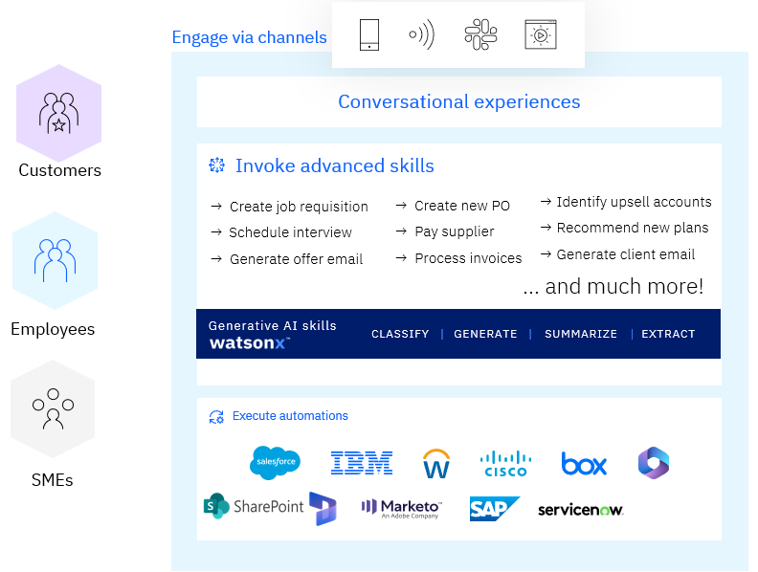

To learn more, follow the links below:

* Official product site: <https://www.ibm.com/products/watsonx-orchestrate>
* Product documentation: <https://www.ibm.com/docs/en/watson-orchestrate>
* Case studies, videos and blogs: <https://www.ibm.com/products/watsonx-orchestrate/resources>
* Community: <https://community.ibm.com/community/user/automation/communities/community-home?CommunityKey=3ad46381-9535-462e-85c9-568b21f4b067>

## Lab Overview

This lab shows how IBM watson**x** Orchestrate can be used by sales representatives to assist with the upsell / cross-sell process. To illustrate this, an insurance seller uses Orchestrate to retrieve a list of customers from Salesforce and automatically send a customized offer. The scenario is based on a skill flow that uses the following custom skills:

1) data retrieval from Salesforce,

2) decision automation to determine the best products to upsell,

3) watson**x**.ai generative AI to create the offer email to the customer

4) send as an email to the selected customer

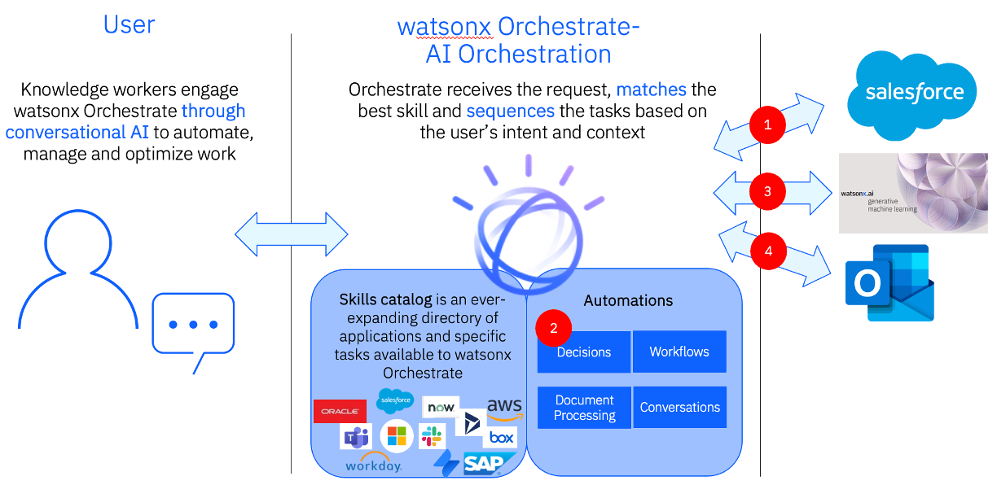

You will first run through the user scenario using Team Skills (pre-published and managed by your tenant admin) and then explore how to build and configure such a scenario as an Orchestrate builder.

In the second part of the lab you will learn how to use out-of-the-box generative AI based automation in watsonx Orchestrate.

## Log in to watsonx Orchestrate

First, you must log in to watson**x** Orchestrate.

1. [Create an IBM ID](https://www.ibm.com/account/reg/us-en/subscribe?formid=urx-19776) if you haven’t already
2. Enter the URL <https://dl.watson-orchestrate.ibm.com/> into the browser within your lab environment.
3. Enter the username and password **your instructor provided** to login or you may have got an email from the instructor.

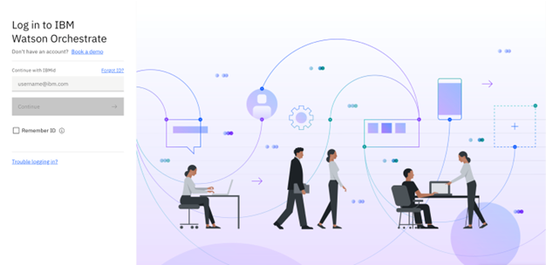

1. Once logged in, the landing page of Orchestrate opens and a **What’s new** guide may appear. If you want, you can see a little tour by clicking the **Let’s go!** button, or you can close the pop up by clicking the **Maybe later** button.

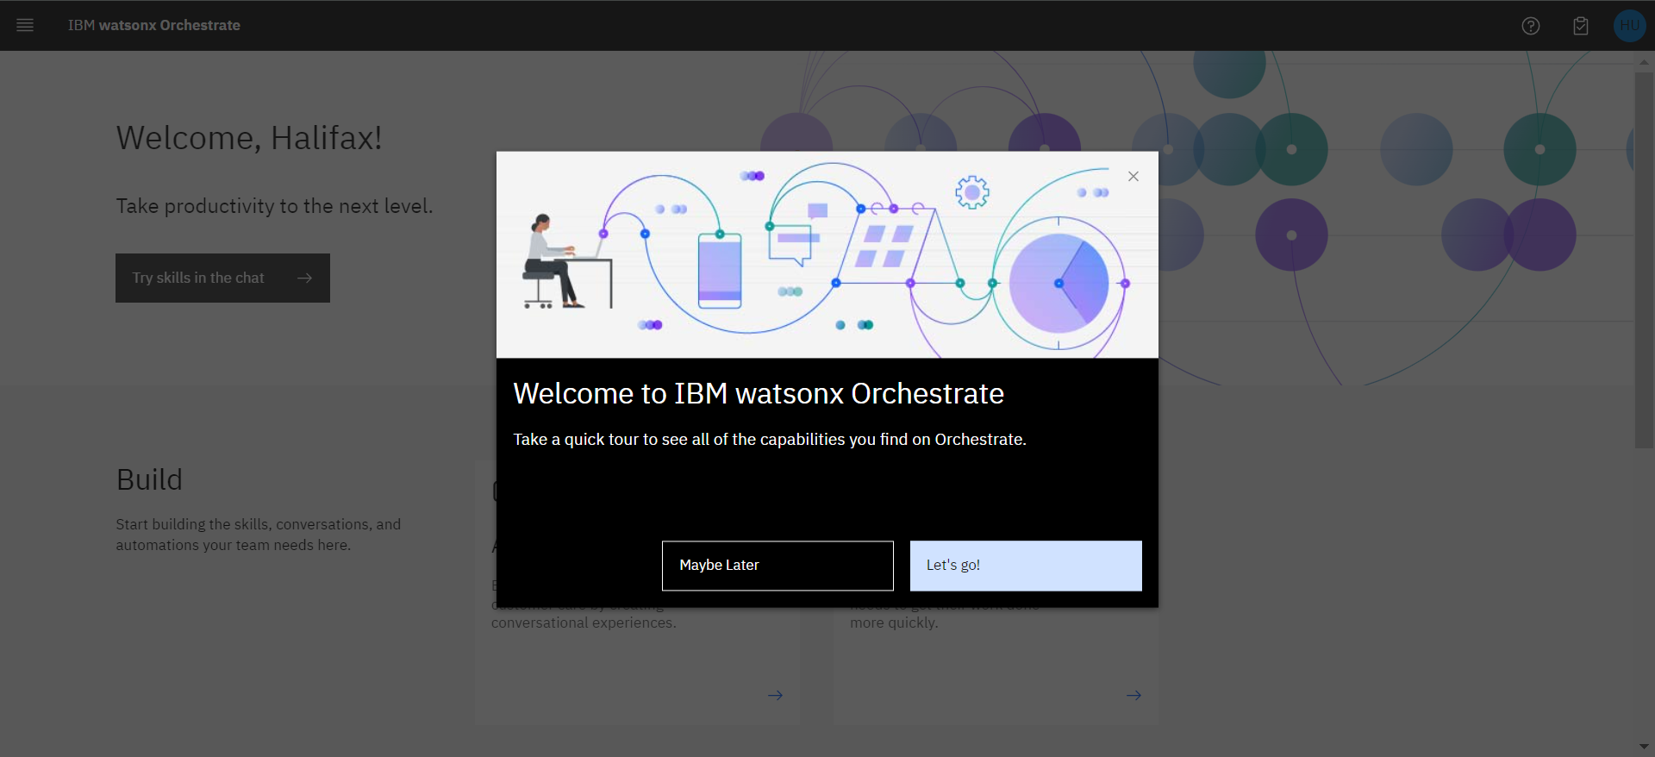

Congratulations, you are now ready to start the lab exercises!

# Run through the preconfigured scenario

A common task for an insurance sales representative is to periodically search the Salesforce CRM for customers with recent life changes to whom they can make upsell / cross-sell offers. Traditionally, this task involves creating custom Salesforce reports and downloading them for manual review by the representative.

In Orchestrate, the agent invokes the Salesforce task using the simple natural language phrase: “*Write upsell email to customers*”. Orchestrate uses AI to understand the sales representative’s intent and performs the correct action, even when the language used is ambiguous.

1. From the landing page, click the **Try skills in the chat** button.

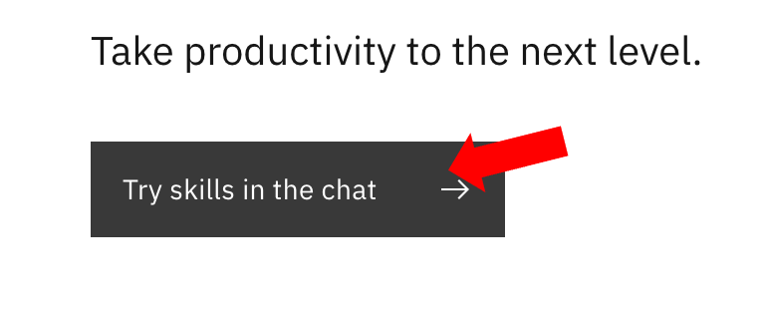

If you already moved away from the landing page to explore other views, click on the menu at the top left and click **Chat**.

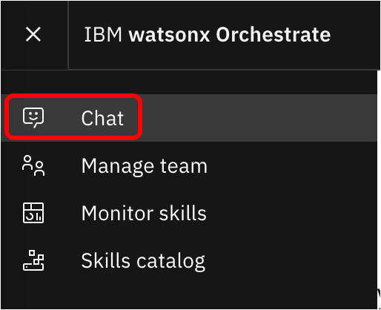

1. Switch the view to **Team skills**.

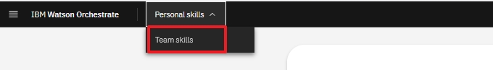

1. Type the natural language command “***Write an upsell email to my customers***” (1) and click the Send arrow (2) or hit ENTER in the chat window.

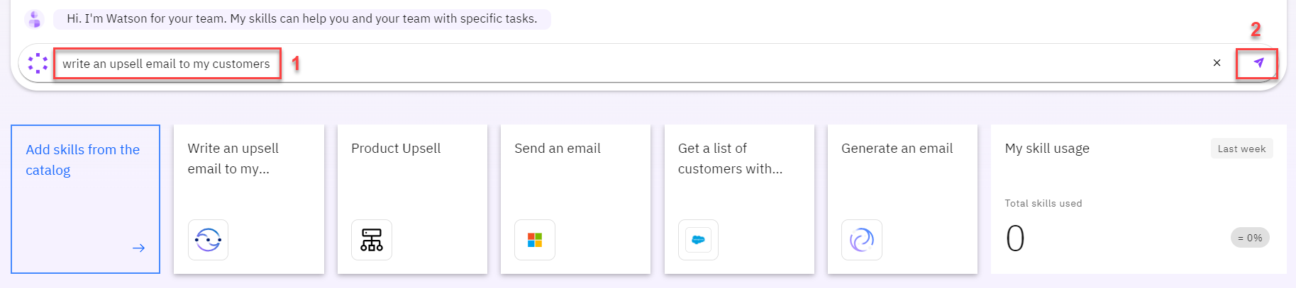

Orchestrate runs the Salesforce task by connecting to a backend API that retrieves a list of customers with recent life changes. The returned customer data is neatly displayed in a table within Orchestrate’s chat interface.

The agent reviews the list of customers and pursues a cross-sell opportunity with **John Collins**, who has a child that is about to turn twenty-six. In the US, twenty-six is a milestone requiring children to acquire independent health insurance coverage (other countries set different age limits for various family milestones).

1. Select **John Collins** (1) from the table and click **Apply** (2) in the chat window.

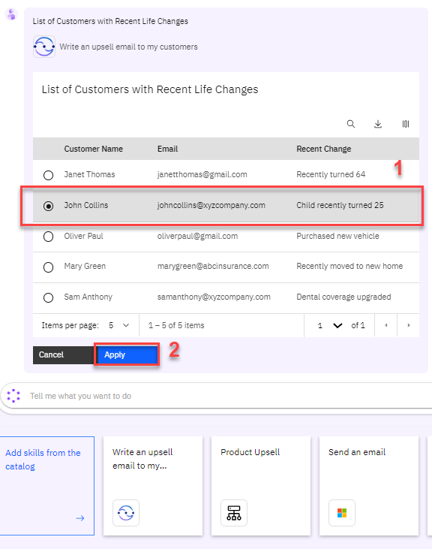

1. The next task is to determine which products to recommend for the selected customer. The customer details from Salesforce are automatically submitted into Orchestrate’s built-in *decision engine* and the upsell recommendations are displayed.

Behind the scenes, the decision engine applied business logic using many different factors specific to this customer, such as the child’s age, pre-existing conditions, and current coverage.

In the case of John Collins, the decision engine recommends the health insurance plans suitable for his child: Silver-level Marketplace Plan.

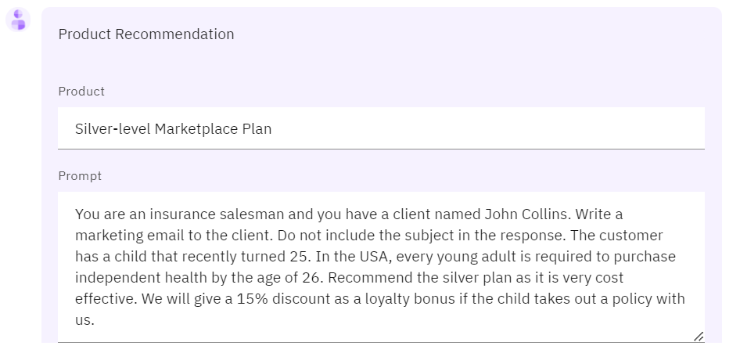

Review the recommendation from the decision engine and Click **Apply**.

1. Personalized emails increase the likelihood of sales conversion. IBM watson**x** Orchestrate uses one of IBM’s Large Language Models (LLMs) via the watson**x**.ai platform to generate a targeted email for the selected customer.

In the prompt field, seethe default input text with the suggested prompt (1) to see how Orchestrate engineered the prompt using data taken from the decision engine and Salesforce. Click **Apply** (2).

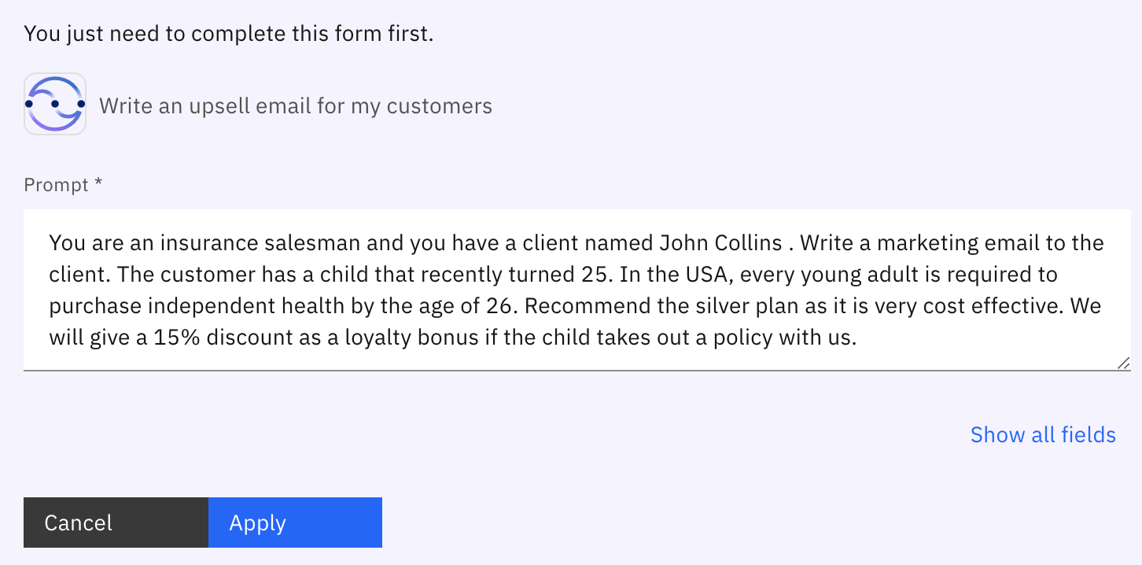

**NOTE!** *Perfecting the AI prompt to generate a properly formatted email is typically a time-consuming activity. To make this quicker, Orchestrate automatically inserts a pre-written AI prompt that includes dynamically inserted customer data in the prompt input field. This step is also something that we might choose not to show to the user, but we again want to show it here for you to see what’s going on behind the scenes.*

Orchestrate launches its pre-built Microsoft Outlook skill to send an email without the sales representative leaving the Orchestrate user interface to use an email client. In addition to pre-populating the **To** and **Subject** fields, Orchestrate automatically inserts the AI-generated text into the **Content** field.

1. Review the email text generated by IBM watson**x**.ai.



Generative AI did a good job generating the email, don’t you think? Note that your text will likely be a bit different than shown in the picture above.

1. Change the email address in the **To** (1) field to your own email address (one that you can access to verify the email sending). Scroll down and click **Apply** (2) in the watson**x** Orchestrate chat window.

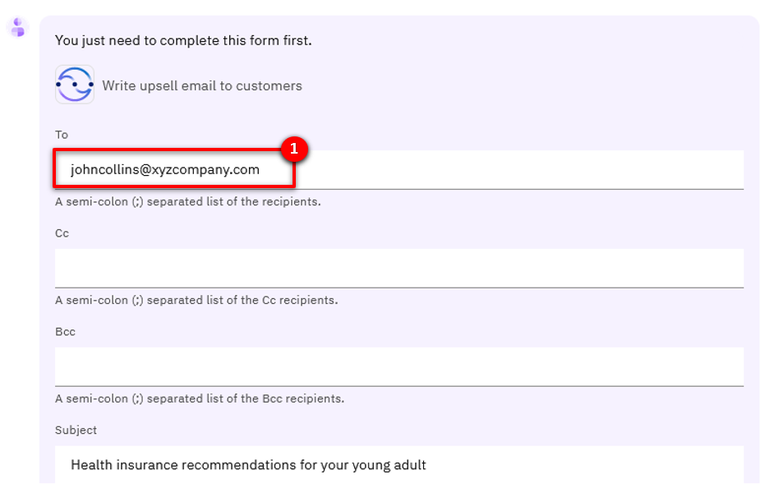

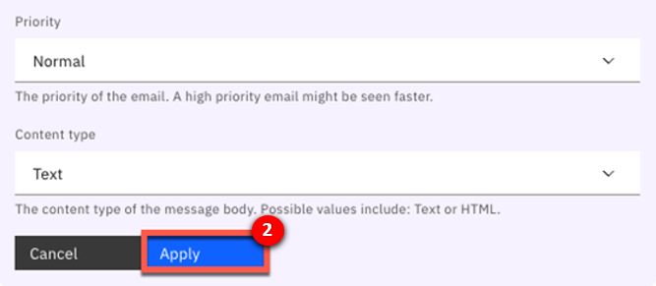

Give it a moment and you should be able to see the email sent by Orchestrate in your inbox.



This concludes section two of this lab. Good job!

Next, we will look closer at how to build and configure one part of the scenario using the skills in Orchestrate’s skill catalogue.

# Combine skills into skill flows

IBM watson**x** Orchestrate provides access to a broad range of skills that help users perform their daily tasks. It comes with a collection of ready-to-use, built-in skills that range from working with productivity tools to providing deep analytical insights. Users can immediately access and use these skills.

Developers, called “builders”, can import and create all kinds of custom skills like the ones used by the insurance sales representatives in our lab scenario. Builders can also create **skill flows**, or a sequence of individual skills. When a skill flow is created, it becomes a new “composite” skill that can be used just like an individual skill. The skill flow for the scenario you just ran through is presented in the picture below.

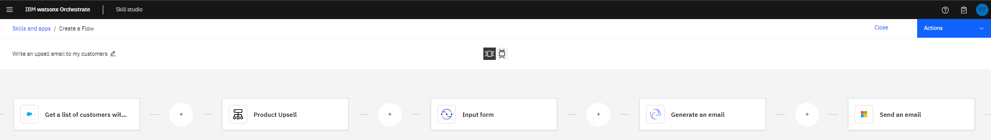

Skill flows perform tasks composed of multiple steps. For example, in our scenario we use a skill flow that combined *Salesforce*, *a product recommendation engine* (decision automation), a *watsonx.ai generative AI service*, and *sending email using Outlook*.

We’ll now look at how builders create skill flows by sequencing the first two steps of the upsell task performed by the agent. We’ll combine the Salesforce and recommendation engine skills to build a new composite skill flow that searches Salesforce for target customers and then makes product recommendations for a selected customer.

## Adding custom skills to your personal skills

Before we can start building the skill flow, we need to add all the skills to our personal skills list. The custom skills we’re using for this part of the lab are already imported and published to the skill catalog, but to use them you need to connect them with your credentials and add them to your personal skills list. Let’s get to it!

1. Make sure to select **Personal skills** at the top of the Chat view.

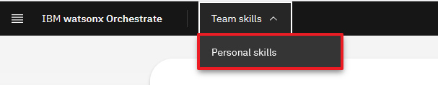

1. Click the **Add skills from the catalog** tile.

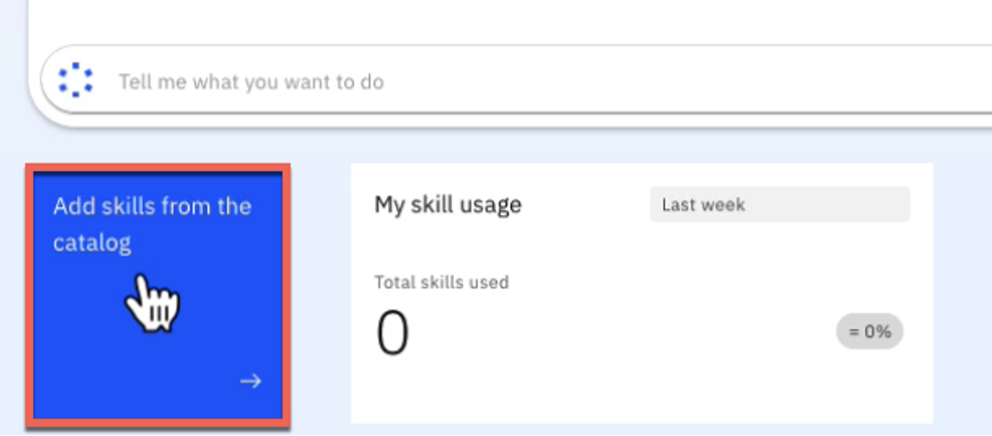

1. Search for **life** in the search panel.

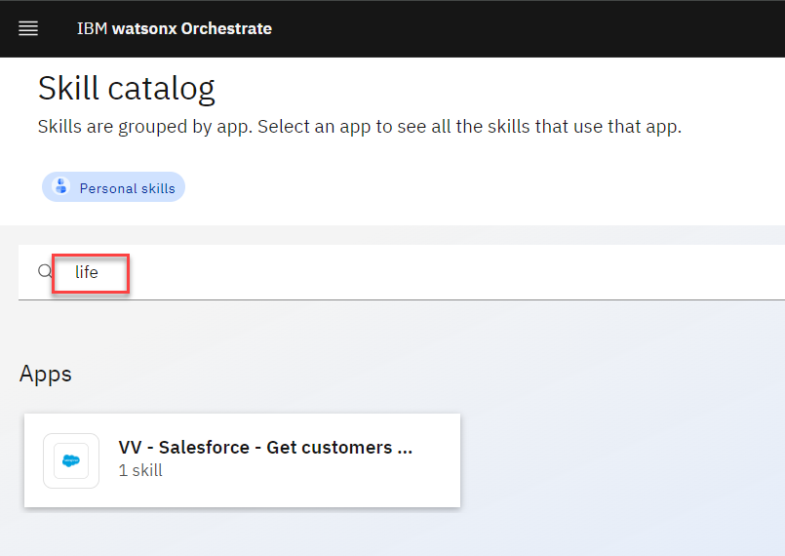

1. The list of apps is filtered to only those that contain skills containing the word “life”. Click the **VV – Salesforce – Get customers with recent life changes** tile.

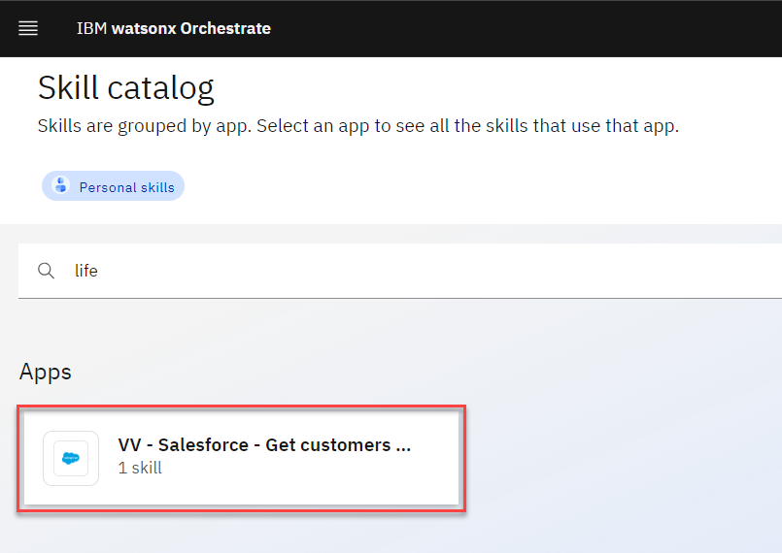

1. Click **Add skill +** (1) on the skill tile, then click **Connect app** (2).

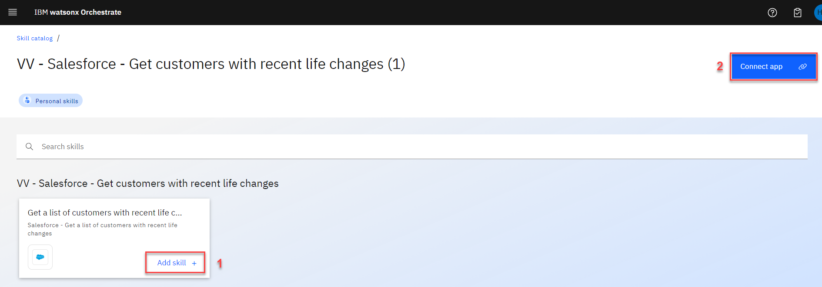

1. Use the following credentials:

* **Client ID** (1): 3MVG9HB6vm3GZZR_fBoKSxSomjQ8ZaShg9mWyjw2pJak55hcL8KGtUjjkooS7wpLD25QraIBxop4ThrTPK237
* **Client Secret** (2): 34CB8CCE1E4495C0CAE6A921A5FC7D17CC6CE614152175D20F5B00F8B250626C

Click **Connect app** (3).

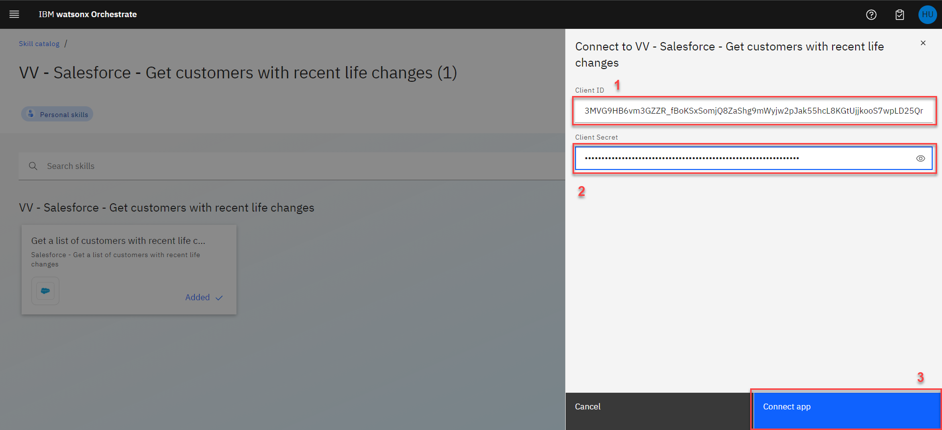

1. Click the main menu at top left.

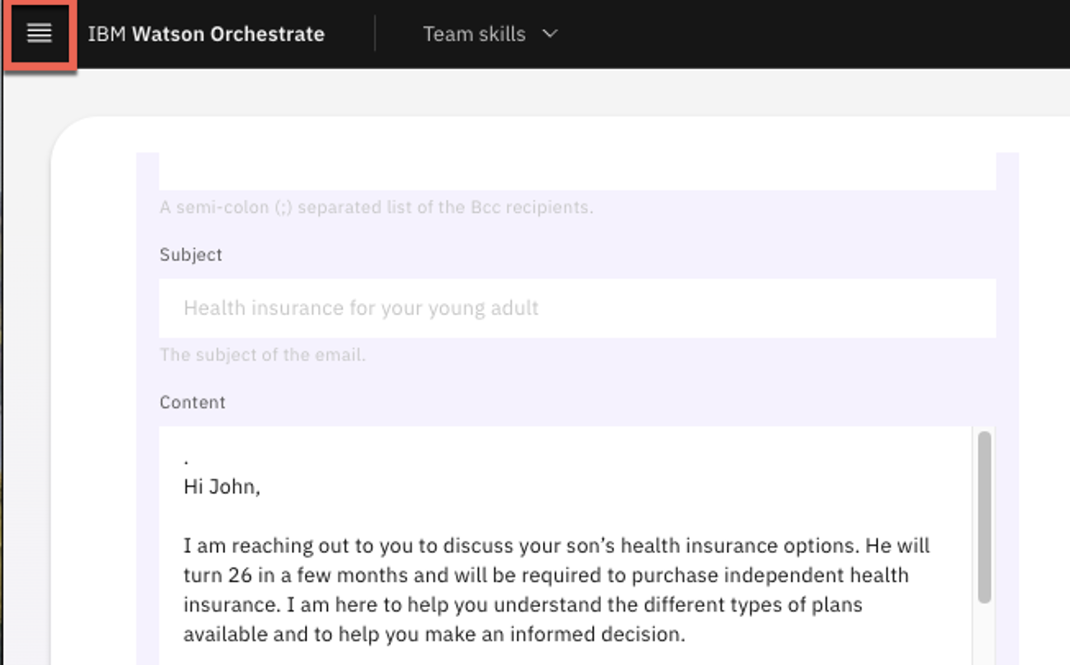

1. Click **Chat** from the expanded menu.

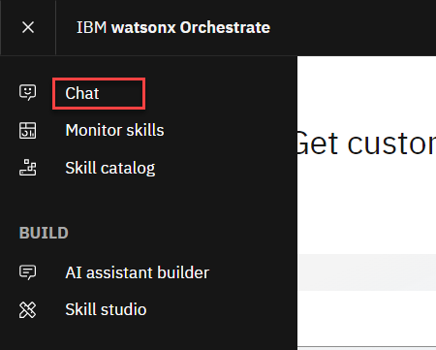

1. You can now test the skill. Click the tile for the skill in your personal skills list under the chat input area.

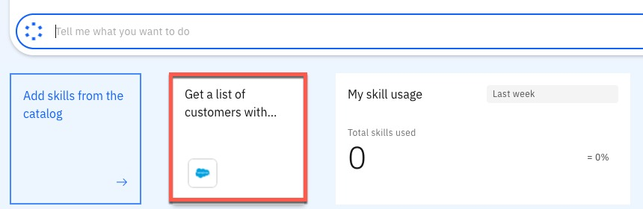

1. After a couple of seconds, a table should be shown containing the data from Salesforce.

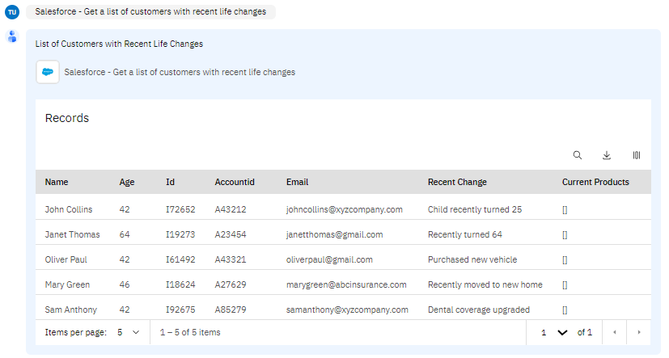

Congratulations! Let’s add another skill to your personal skills list, a decision automation authored using Orchestrate’s Automation Builder. This is the skill responsible of making the upsell suggestion for the selected customer.

1. Click **Add skills from the catalog**.

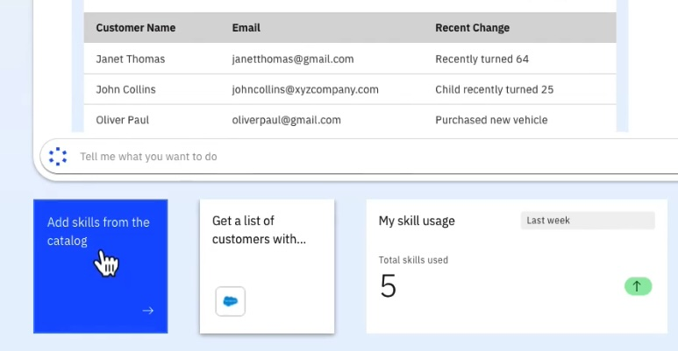

1. Search for **Upsell** in the search panel.

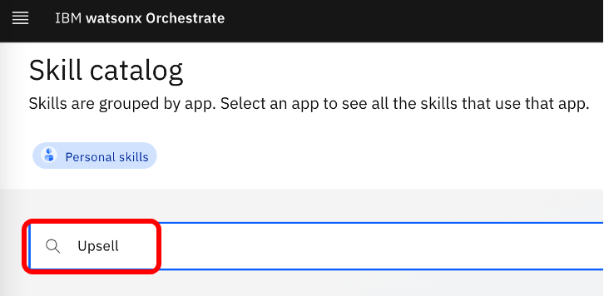

1. Click **L3_Upsell_Master**.



1. Click **Add skill +**. Since the skill is an automation (decision) created on Orchestrate platform, we do not need to connect to it like we do with most other pre-built or custom skills.

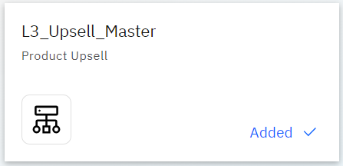

Good! You’re now ready to start creating the skill flow.

## Creating a skill flow

1. Click the menu at top left.



1. Under the Build section, click **Skill studio**. These options are only shown to users with the builder role.

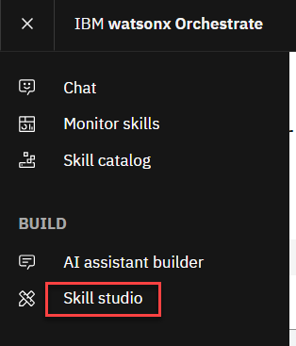

1. Click the arrow next to the **Create skill** button(1), and then **Skill flow** (2).

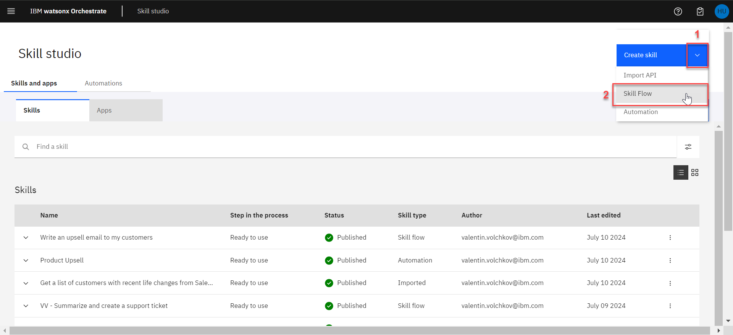

To build skill flows, we can use any skill added to your personal skills list from the skill catalog. You can toggle between horizontal and vertical views based on your preference.



First, we’ll add the Salesforce skill that returns the list of clients who experienced recent life changes.

1. Click the **+** button in the skill flow editor.

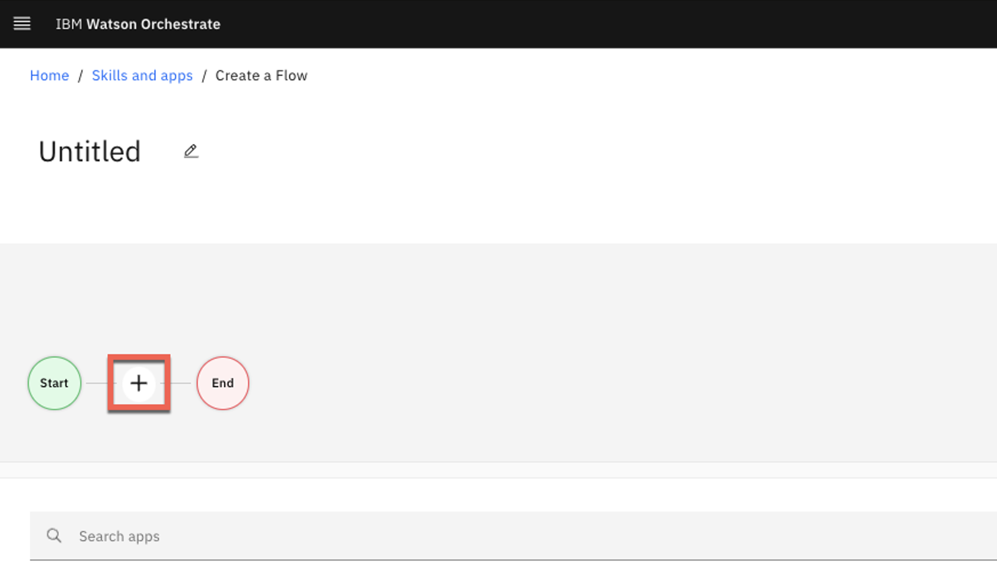

The list of available apps shows the *L3_Upsell_Master* and *VV – Salesforce – Get customers with recent life changes* tiles. These are shown at the top of the list as they are the skills you connected and added to your personal skills list earlier.

1. Click the **VV – Salesforce – Get customers with recent life changes** tile.

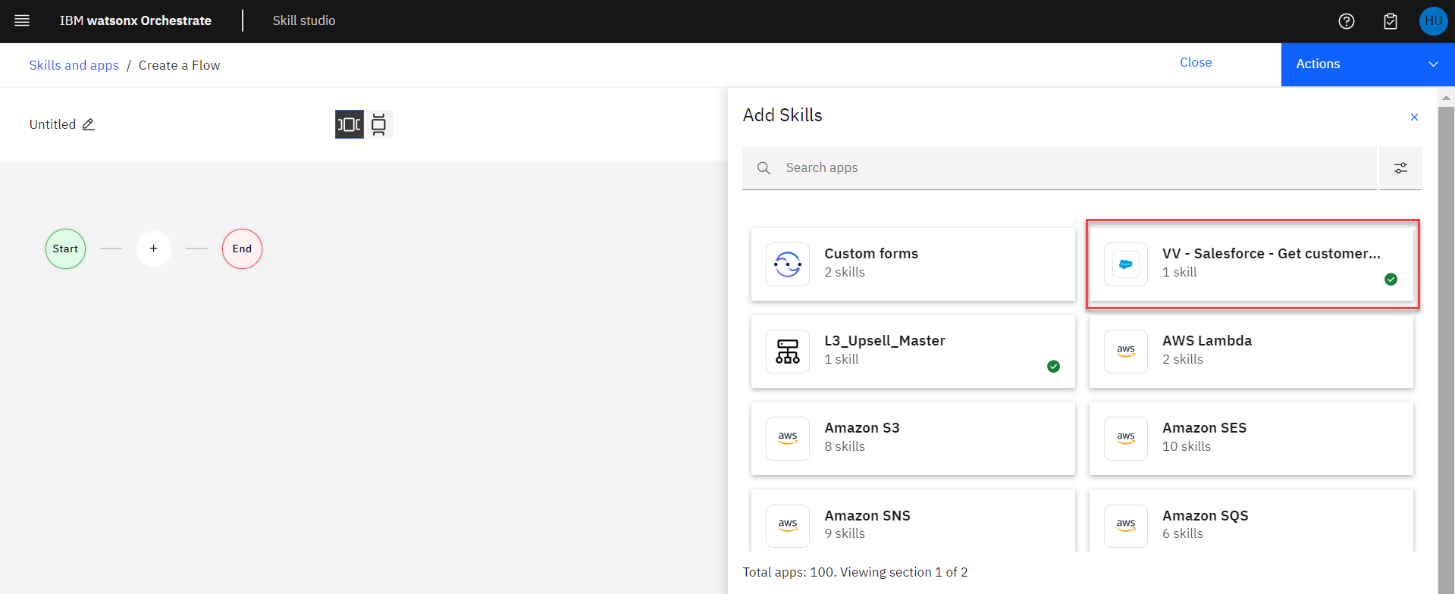

1. Click **Add Skill +**.

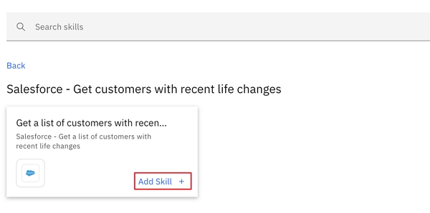

The next step in the flow is to invoke the decision that determines the best product recommendation based on the customer situation. Let’s add the recommendation skill to the flow.

1. Click the **+** button on the right-hand side of the just added Salesforce skill.

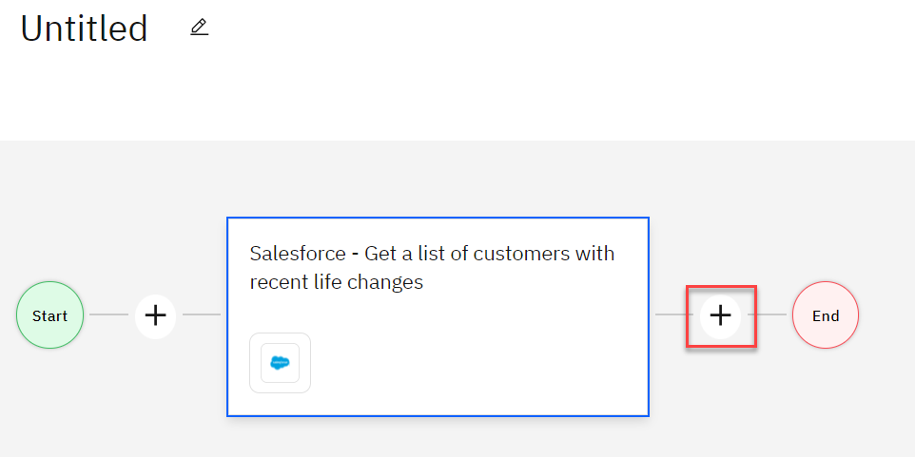

1. Click the **L3_Upsell_Master** tile.

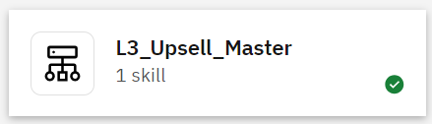

1. Click **Add Skill +**.

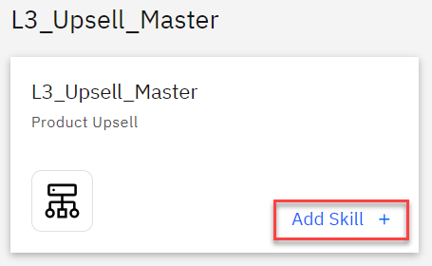

Each skill can have one or more inputs and outputs. The skill flow editor allows builders to easily map the output retrieved from a previous skill in the flow to the input of a subsequent skill. For example, the attributes of the selected customer are available as inputs to the product recommendation decision engine.

1. Click the **L3_Upsell_Master** box within the flow. The property sheet for the skill will appear under the flow.

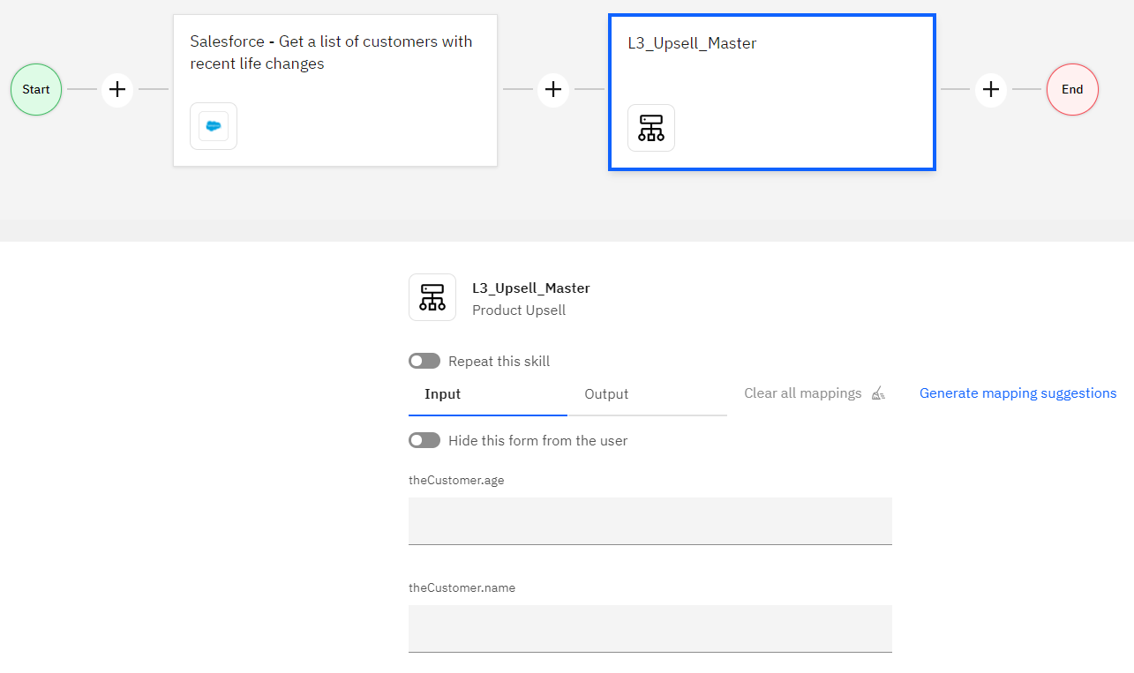

The ‘Input’ and ‘Output’ tabs are used to assign the values. Output values from preceding skills are displayed in the ‘Input’ tab.

1. Click the **Input** tab and then click inside the **theRecentChange** field.

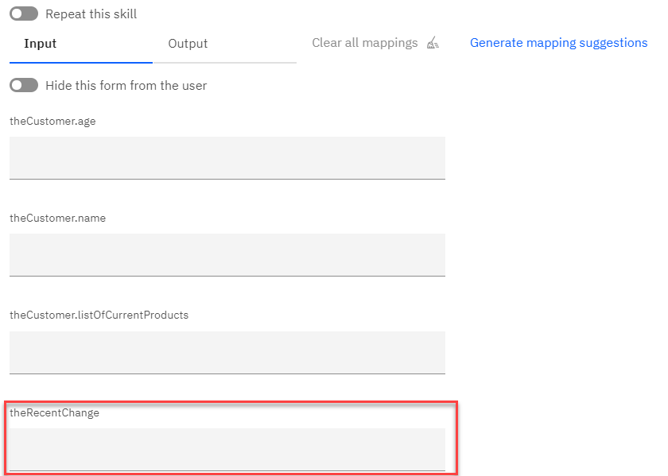

1. Within the **Available Mappings** panel, click the skill that contains the value we need as an input.

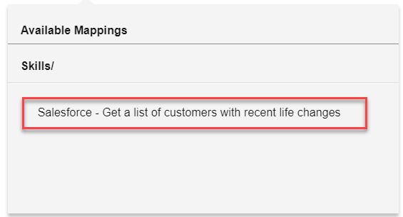

1. Scroll through the available values and select **Recent_Change__c**.

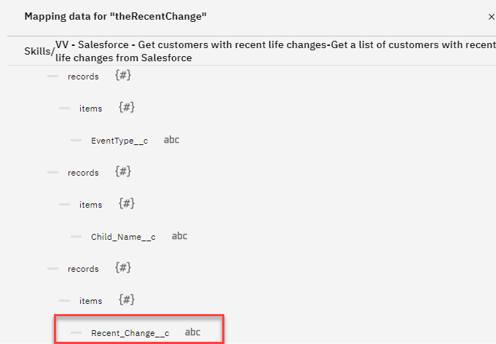

1. The path to the value is now mapped and shown in the field.

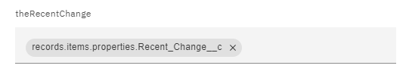

1. Repeat this exercise to map the other two values – **theCustomer.age** and **theCustomer.name**. Do NOT select any Operators for the mappings.

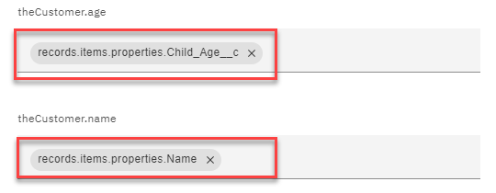

You can also use “Generate mapping suggestions” feature to let watsonx Orchestrate map values for you.

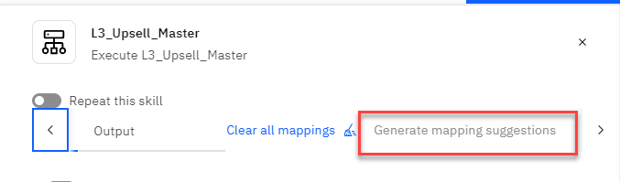

Now we’ll name our new composite skill flow and save it.

1. Click the pencil icon next to **Untitled**.

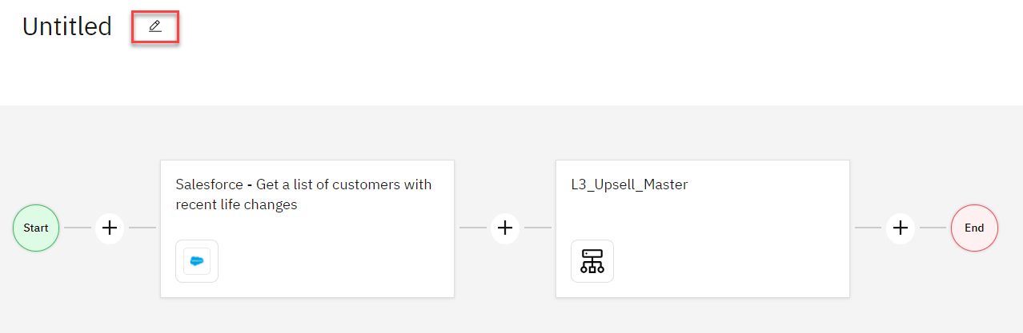

1. In the **Edit Skill flow details**, provide a **Name** for your skill flow, such as “*[****YOUR INITIALS****]-Upsell-Skillflow*” (1), as an example “*GB-Upsell-Skillflow*”, and click **Save** (2).

**NOTE!** *Be sure to use your initials as an identifier in your skill flow name. The Orchestrate environment is shared with other lab participants and you want to find your skill flow with ease*.

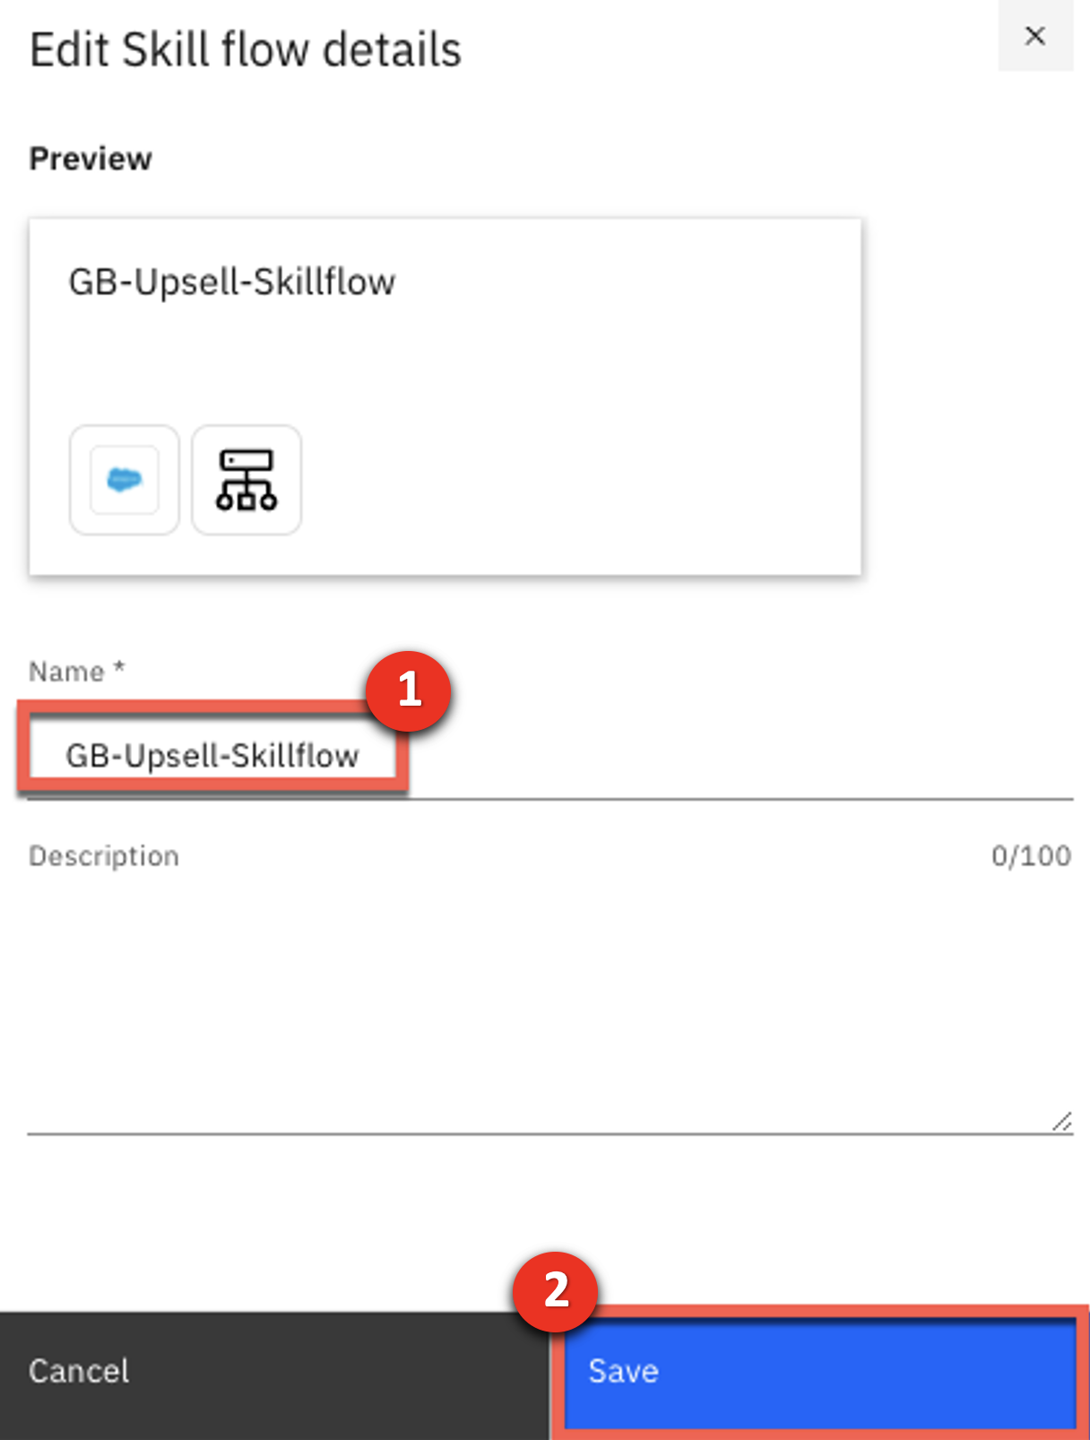

1. Click the arrow next to the **Actions** button (1), and then click **Save as draft** (2).

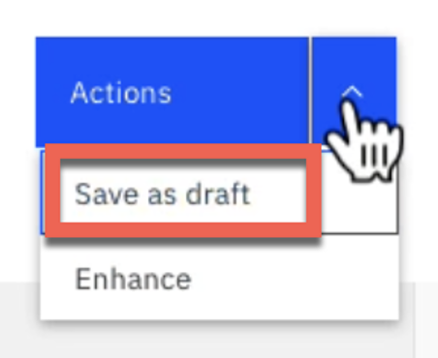

After building the skill flow, we’ll now train the AI model used to trigger the skill from the chat interface. Once the skill is fully trained, we’ll publish it to the watson**x** Orchestrate skill catalog.

1. Click the arrow next to the **Actions** button (1), and then click **Enhance** (2).

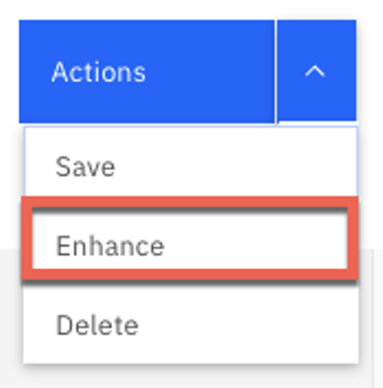

Phrases are used to train the AI model. From the chat interface, watson**x** Orchestrate can understand the user’s intents, and will ask for clarification and give users choices if it isn’t sure which skill to run.

**NOTE!** *As this is a shared environment, it is possible there are many duplicate phrases related to product upsell. Try to provide an original phrase, such as something that includes a name or unrelated term.*

1. Enter a phrase into the first field on the **Phrases** tab, such as **get <YOUR NAME>s upsell hints for customers**, like “get gerrys upsell hints for customers”.

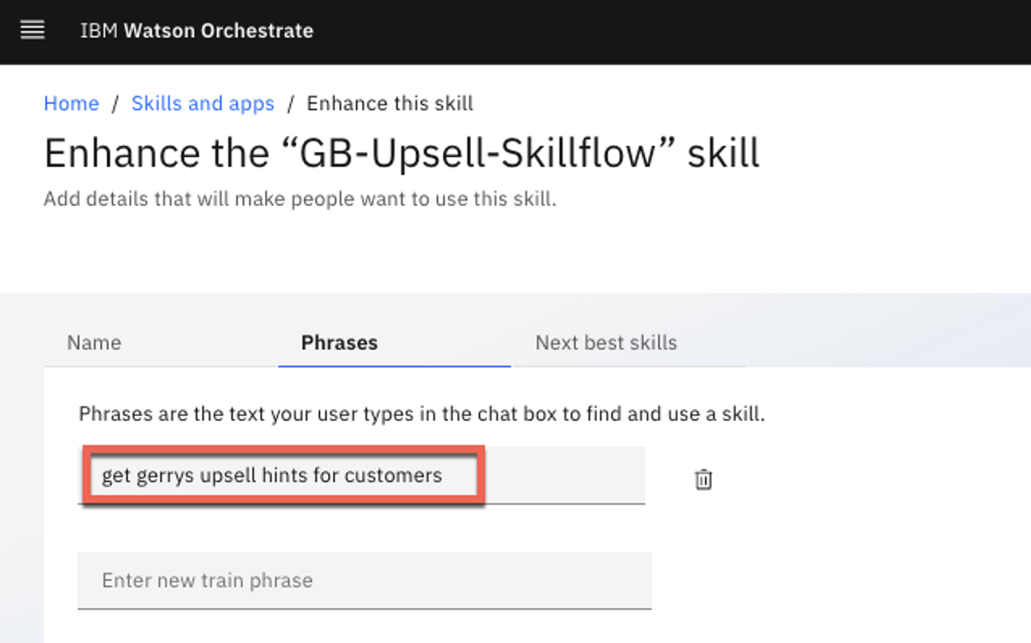

Next, we’ll publish the new flow to the watson**x** Orchestrate skill catalog, so the insurance sales representatives can use it.

1. Click **Publish**.

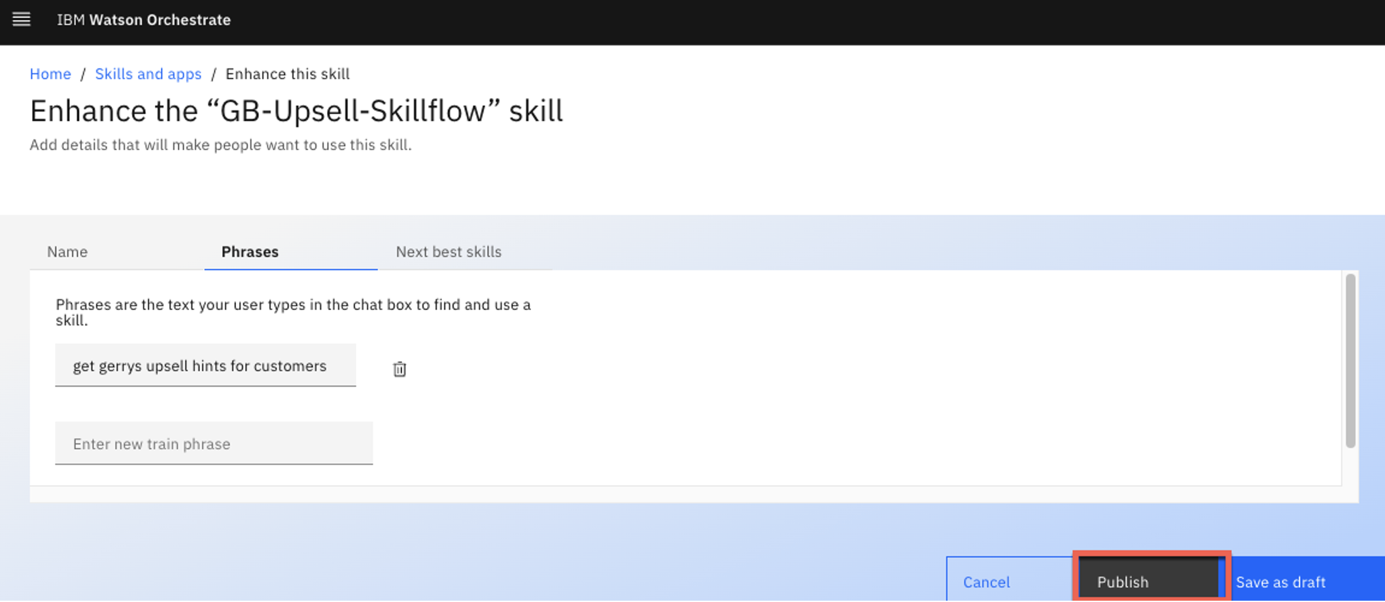

## Using your personal skills list to add and run the skill flow

Since we finished creating and publishing the skill flow, all the insurance sales representatives in the company can now add the skill to their personal skills list.

1. Click the menu and then click **Chat** to return to your main chat view.

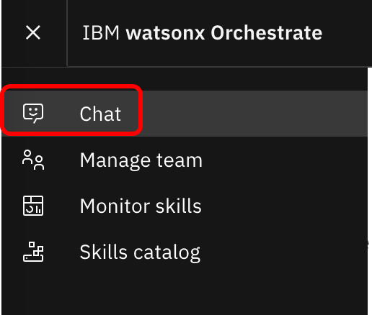

1. Click **Add skills from the catalog**.

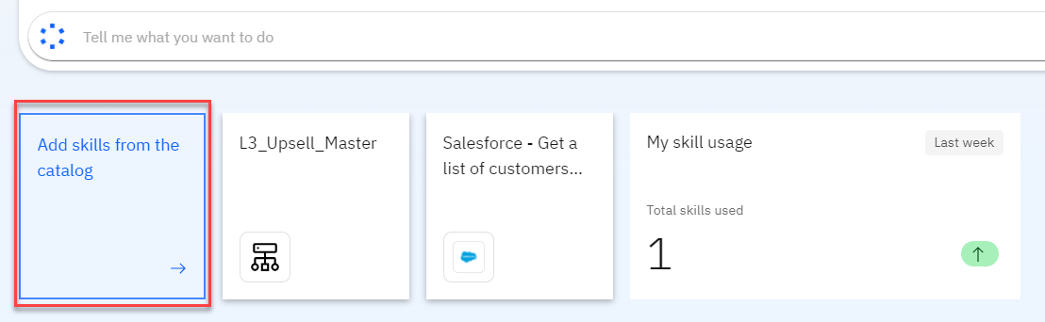

1. Search the catalog with **flows** and click the **Skill flows** tile.

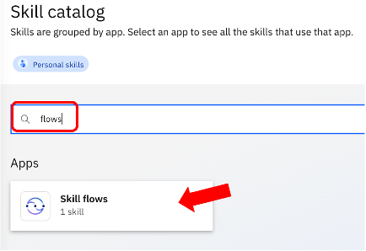

1. In the **Skill flows** view, type **upsell** to find your recently created skill flow, and click **Add skill +** on your skill flow you just created.

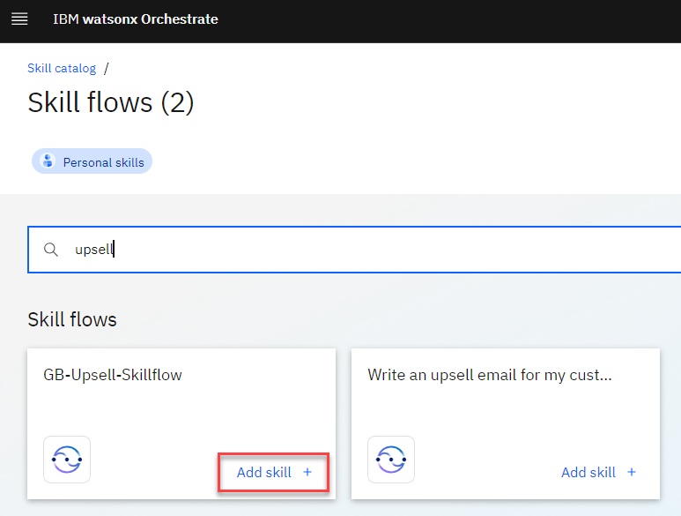

You’re now ready to run your new skill flow by asking watson**x** Orchestrate to find upsell candidates and make product recommendations for the selected customer.

1. Navigate back to your **Chat** view (menu à Chat).
2. Enter the **phrase with your name in it** to run your skill.

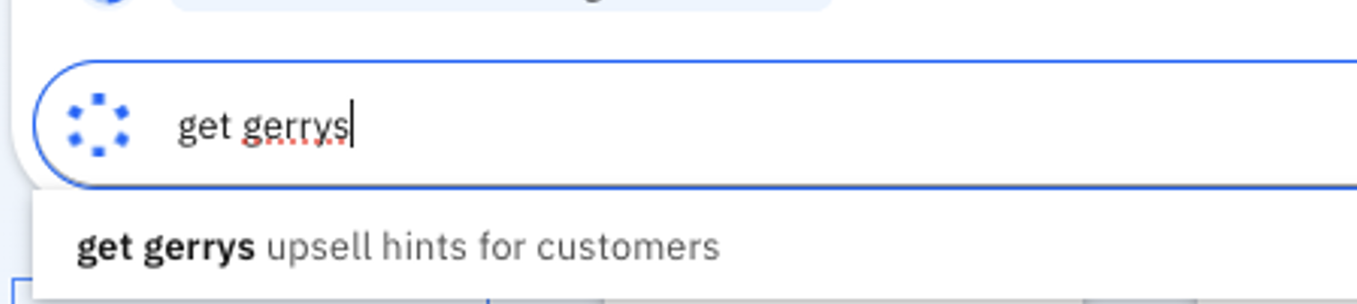

The list of customers is returned, and we’ll select one.

1. Select **John Collins** (1) and click **Apply** (2). Note that when a skill that returns a list of items is defined as part of a skill flow, Orchestrate automatically enables by default selections for the list.

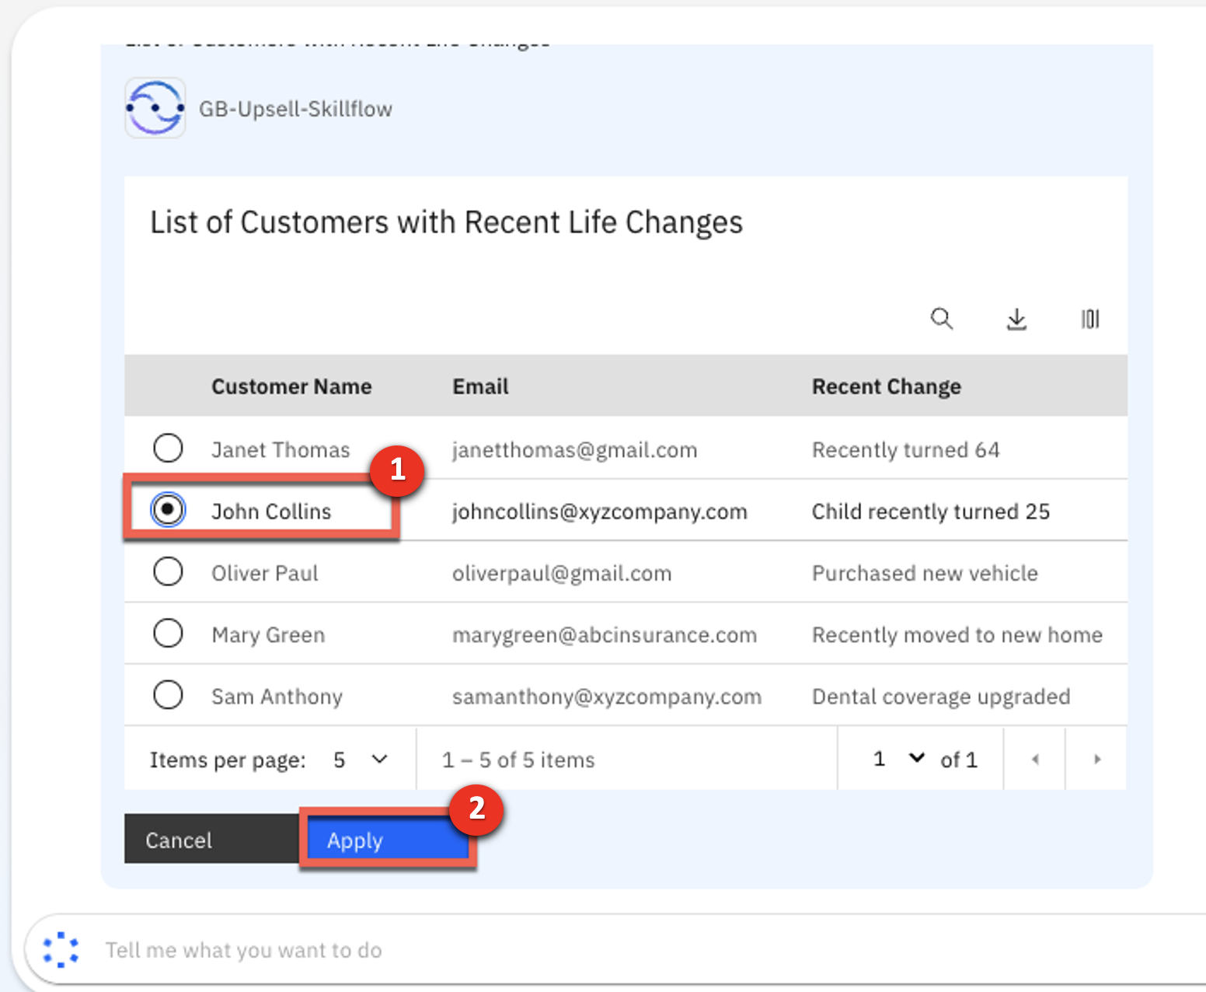

1. The data for Johns Collins is then automatically mapped into the input fields of the product recommendation skill. Review and then click **Apply** to run the second skill in your skill flow.

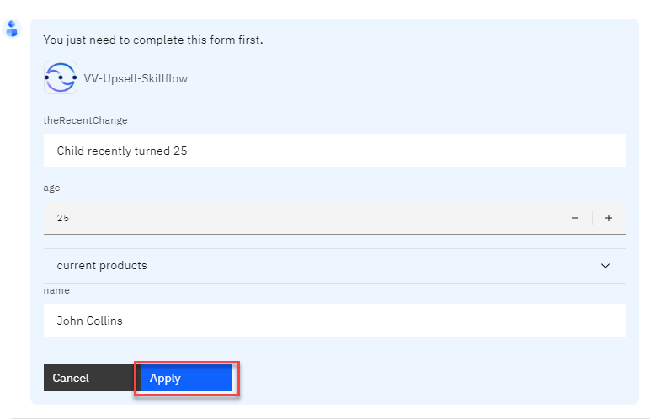

1. Review the result of the upsell decision service.

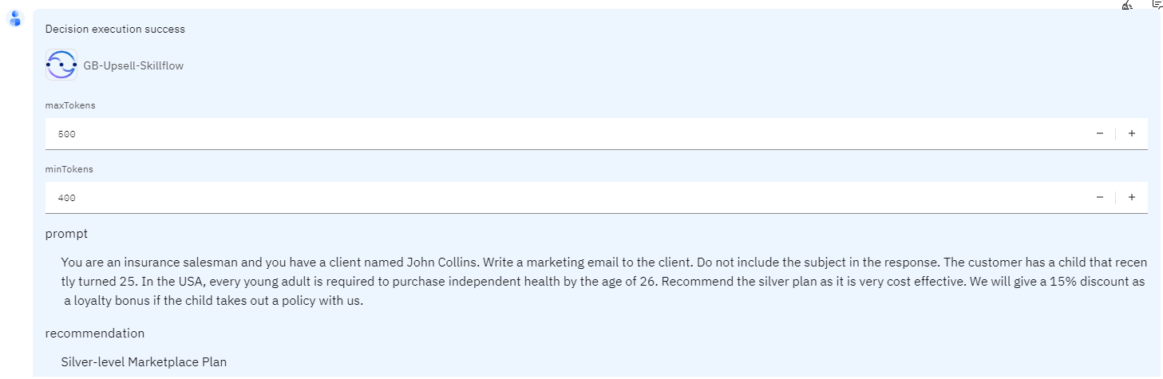

Feel free to explore your skill flow and attached decision skill by selecting users other than John Collins. You should see different recommendations based on customer’s recent change in life situation.

Nice! As a builder, you created and published new skill flow. The skill flow ran successfully and made a product upsell recommendation for the selected customer.

Next, we will have a closer look at the options to import your own custom skills into Orchestrate.

# Import custom skills

As mentioned in the introduction, builders can import custom skills into IBM watson**x** Orchestrate in a few different ways. All available skills – pre-built and custom skills that are already published – can be accessed through the Skills catalog.

To import existing services as skills, you have several options. You’re not going to use them in this lab, but let’s explore them briefly!

1. In the menu, click **Skill studio**.

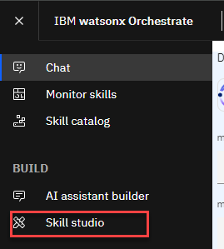

The “Skills and apps” view shows you all the custom skills imported or created (including *skill flows* and published *automations*). Let’s start with the imported ones.

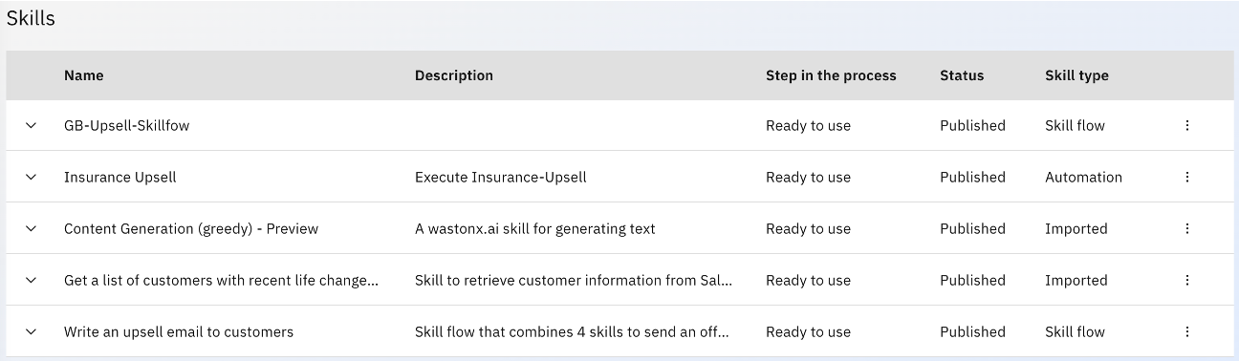

1. Click the **Create skill** button and select **Import API** from the menu.

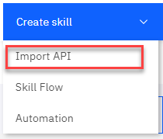

This opens the **Add skills** view and shows you the current options for importing new skills.

The first option allows you to discover available automation services from IBM Cloud Pak for Business Automation (CP4BA) on-premises or SaaS, from IBM RPA or UiPath (more information is available [here](https://www.ibm.com/docs/en/watson-orchestrate?topic=skills-building-from-apps)), as well as from IBM Business Automation Workflow SaaS and IBM Operational Decision Manager SaaS. IBM plans to add support to discover services from other 3rd party platforms in upcoming releases.

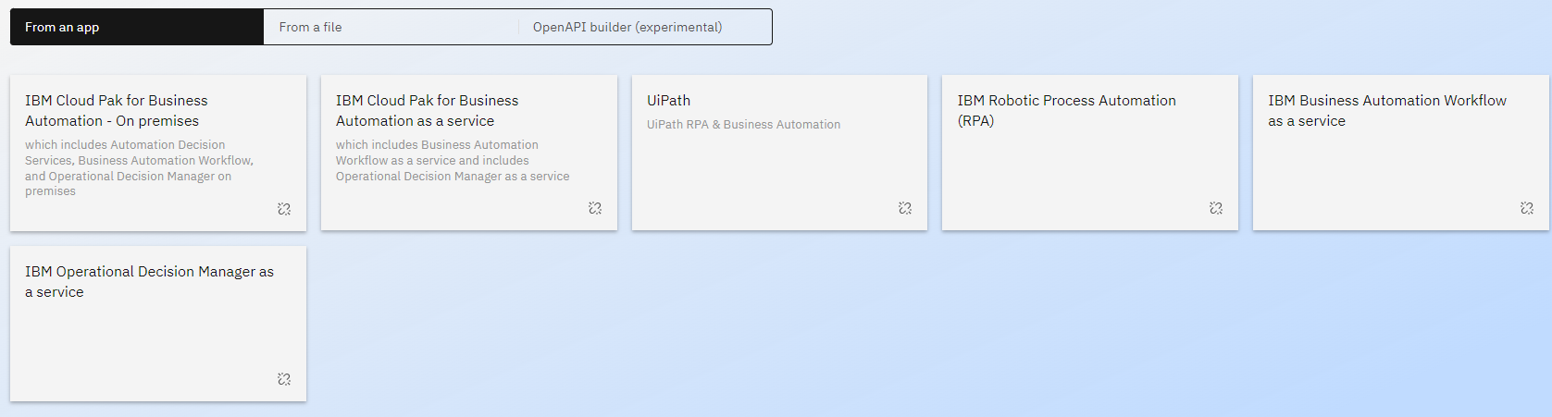

The second option is to import skills using OpenAPI definition files. If you have a service endpoint description as an OpenAPI, you can import it directly to Orchestrate (more information is available [here](https://www.ibm.com/docs/en/watson-orchestrate?topic=skills-building-from-files)).

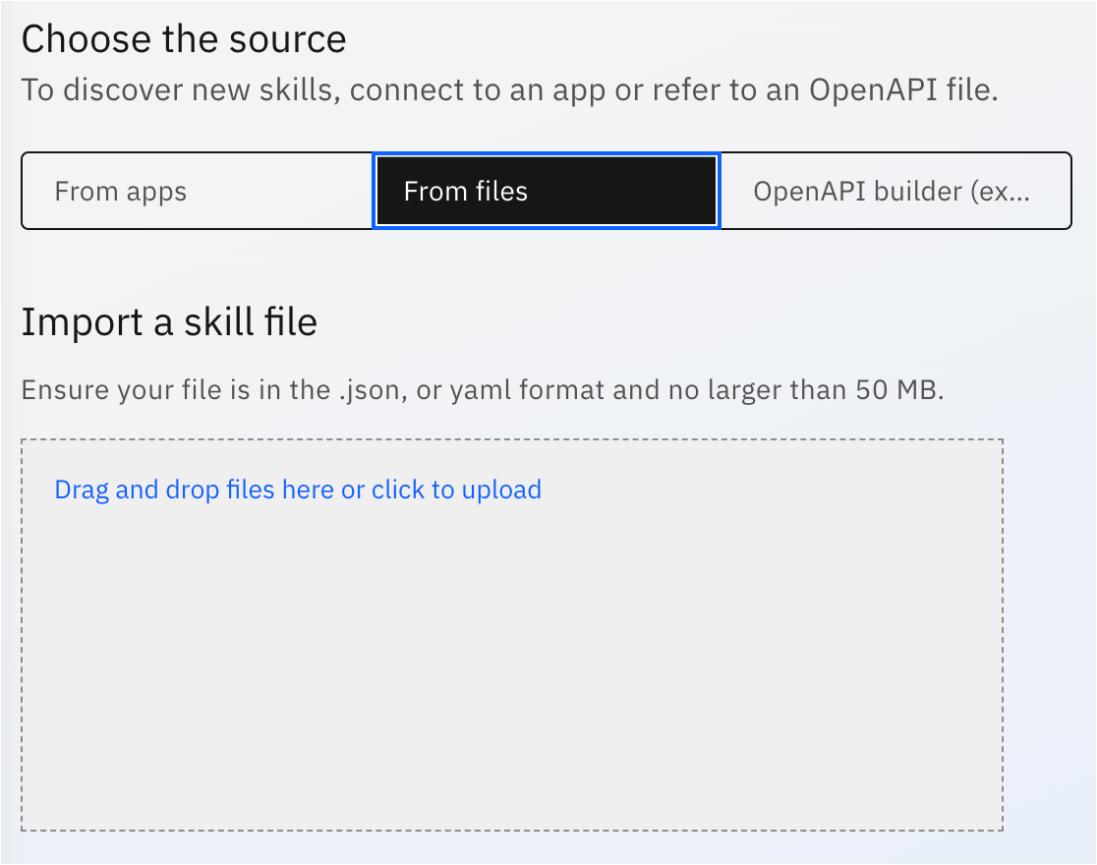

The third option is the **embedded OpenAPI builder** (beta in the current version). A Builder can use it to do the following:

1) have AI generate a new OpenAPI specification from a documentation web page,

2) view and edit an existing OpenAPI specification, or

3) create an OpenAPI specification from scratch (more information is available [here](https://www.ibm.com/docs/en/watson-orchestrate?topic=skills-building-openapi-specifications)).

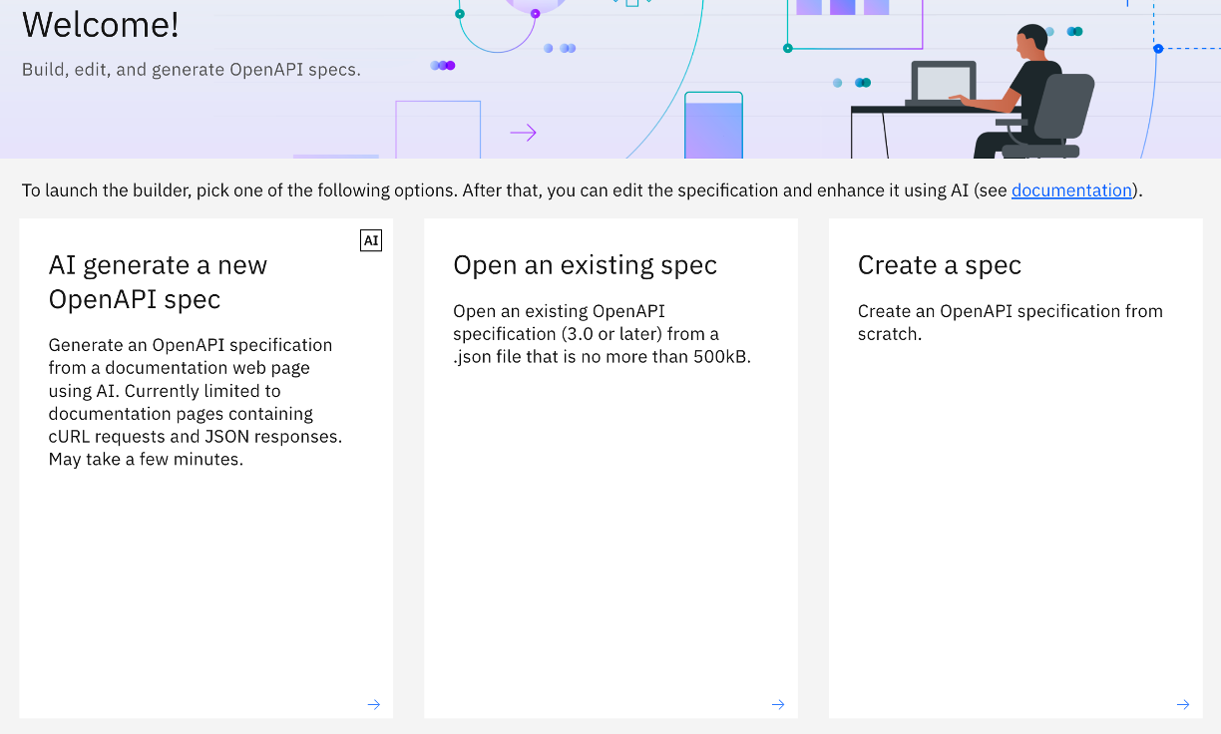

# Build automations

IBM watson**x** Orchestrate also includes embedded tools to create new automations and publish them as skills to provide support for more complex scenarios and further automate work.

## Decisions

Decisions are an automation type that capture and automate repeatable intelligent **business decisions**. For example, a business decision to authorize a loan, based on established rules and policies. A decision can be implemented with *decision models*, *ruleflow models*, and *prediction models*.

***Decision models*** offer a straightforward and low-code approach to modeling business decisions through a structured, visual representation of a decision. Orchestrate provides low-code tooling to create, test, deploy, and publish decision models as skills. More information about creating decision models [here](https://www.ibm.com/docs/en/watson-orchestrate?topic=decisions-building-decision-models).

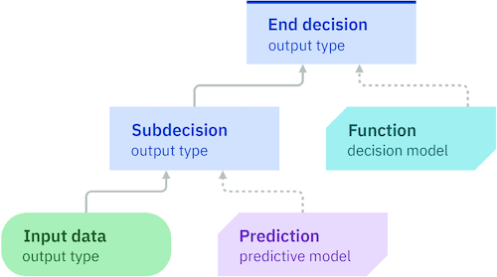

***Ruleflow models*** offer a more advanced way to define decisions with control over the order of steps and branching of your decision logic.

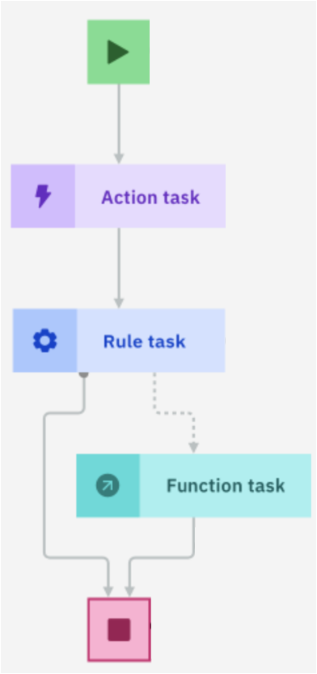

***Prediction models*** offer insights from historical data to help you make more informed decisions. Use prediction models to compute a prediction that you can use as part of a decision or ruleflow model. Three remote providers are supported: IBM Watson® Machine Learning, Amazon® SageMaker, and IBM® Open Prediction Service.

Open Prediction Service is an extension framework that allows you to connect to machine learning providers that are not natively supported. This includes custom machine learning services and third-party machine learning tools, such as Microsoft® Azure Machine Learning. For more information about Open Prediction Service, see the [Open Prediction Service Hub repository](https://github.com/IBM/open-prediction-service-hub).

An **embedded machine learning provider** is also supported. This provider allows you to import Predictive Model Markup Language (PMML) files and run them directly in Orchestrate. More about building and using prediction models [here](https://www.ibm.com/docs/en/watson-orchestrate?topic=decisions-building-prediction-models).

## Workflows

Workflow is an automation component that models a **business process**. For example, a process to find and hire candidates for a job. A workflow is composed of a sequence of activities and tasks. These activities can be other workflows, decisions, automations, or skills, which you can put together to create powerful automations and **publish as skills** in the Orchestrate skills catalog.

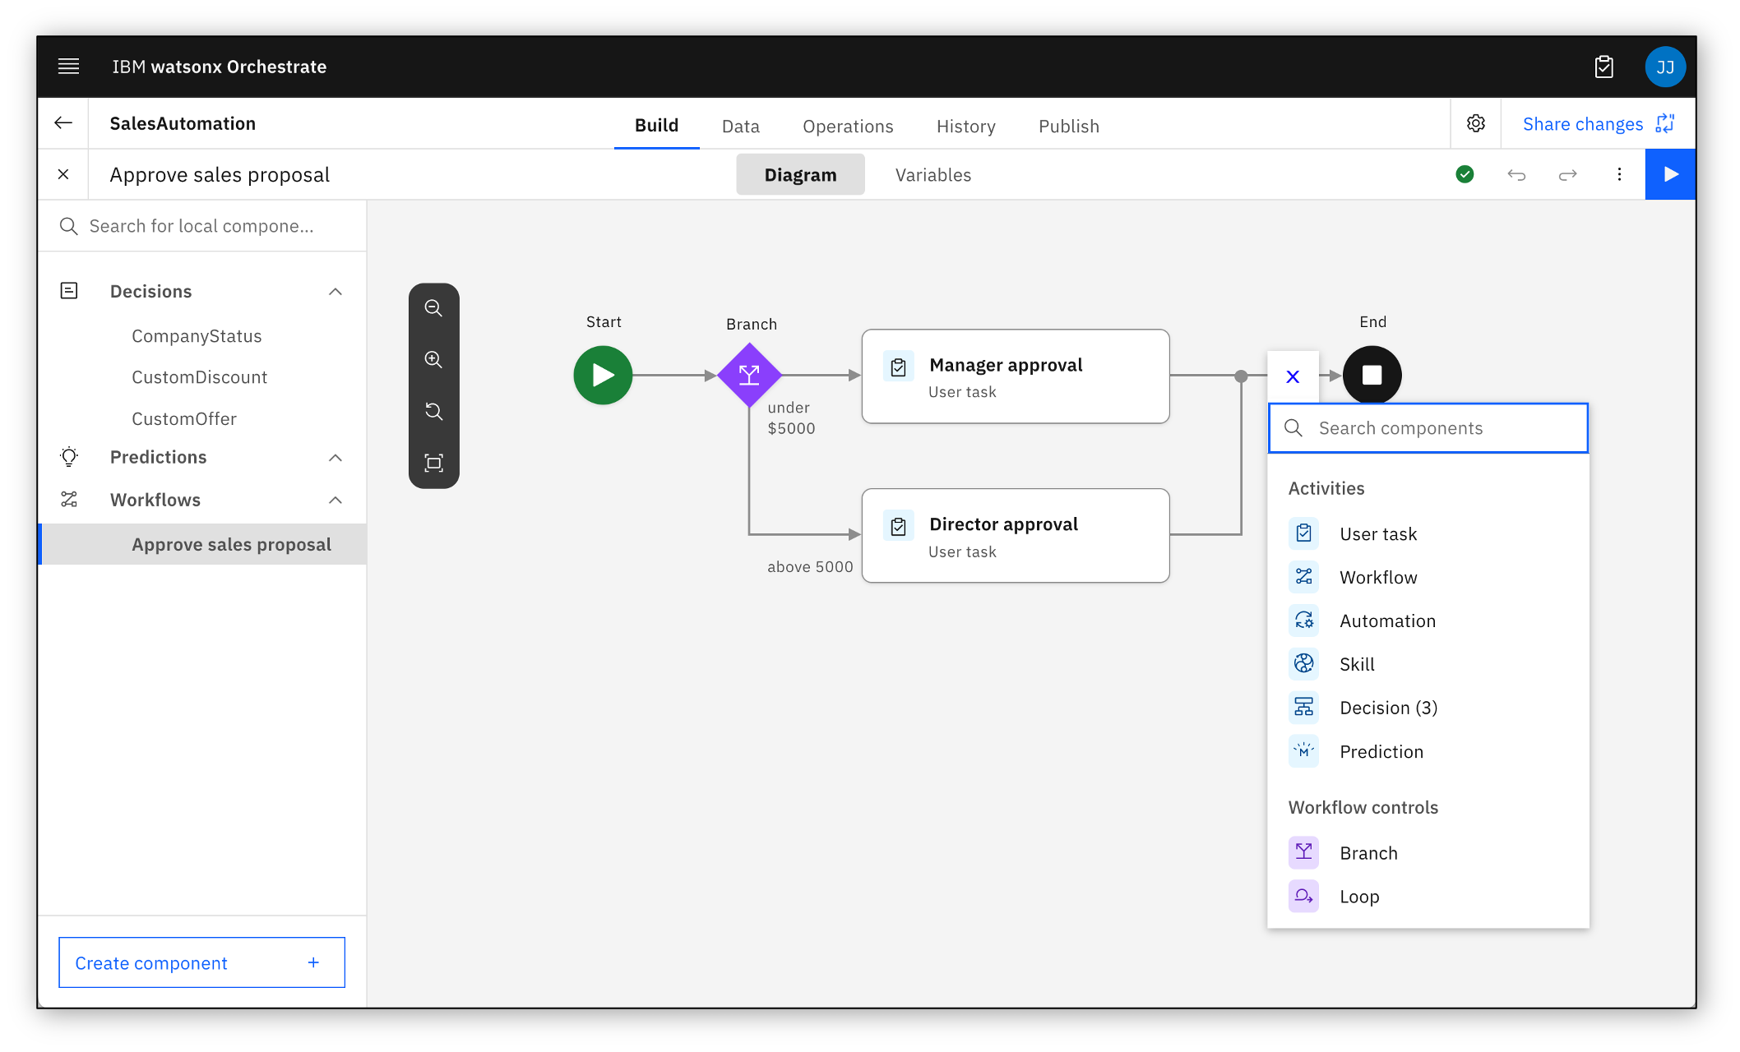

You can think of the workflow capability as more advanced skill flow editor, where you can branch out to different activities and create collaborative flows by assigning user tasks to different Orchestrate users. More about using workflows [here](https://www.ibm.com/docs/en/watson-orchestrate?topic=automations-creating-workflows).

## Generative AI

In this lab you will learn how to use an out-of-the-box generative AI based automation in watsonx Orchestrate. For example, to create a summary of customer support tickets, you can leverage watsonx.ai with few-shot prompting. This can be configured as a generative AI automation skill in IBM watsonx Orchestrate.

### Creating Generative AI Automation in watsonx Orchestrate

1. Click on the hamburger menu in watsonx Orchestrate and select **Skill studio**.

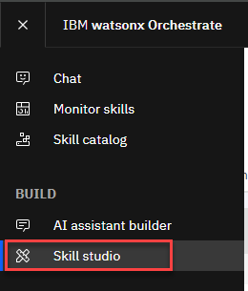

1. Then click on **Create skill** and select **Automation** from the drop-down menu.

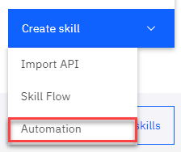

1. Provide the **Name** for your automation ("TicketSummarization") and an optional **Description**, then click **Create**.

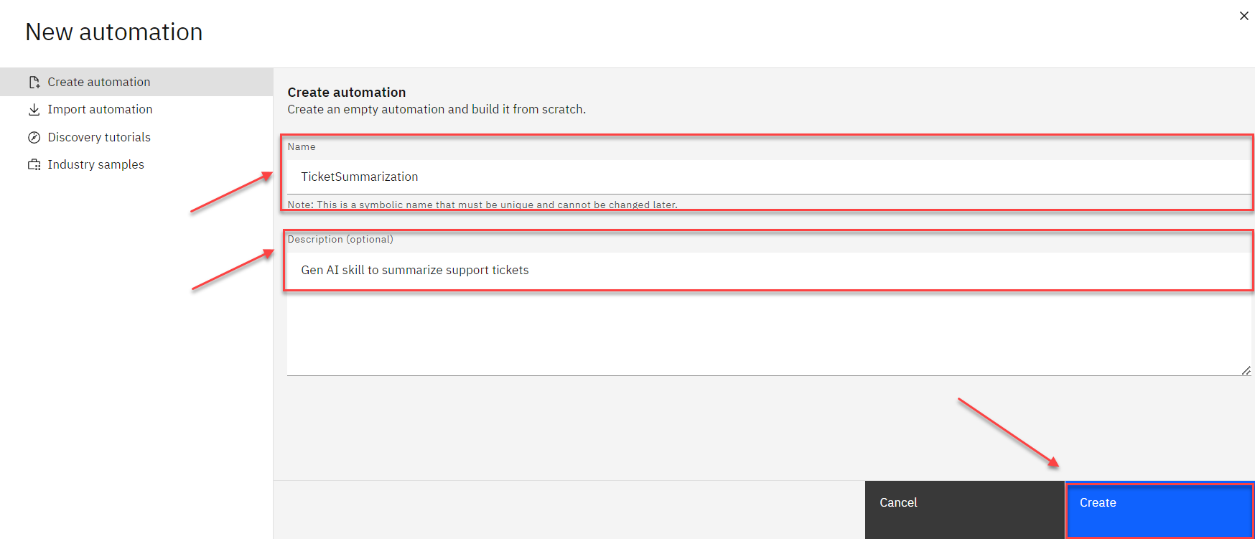

1. Select **Generative AI** component for your new automation in the next screen.

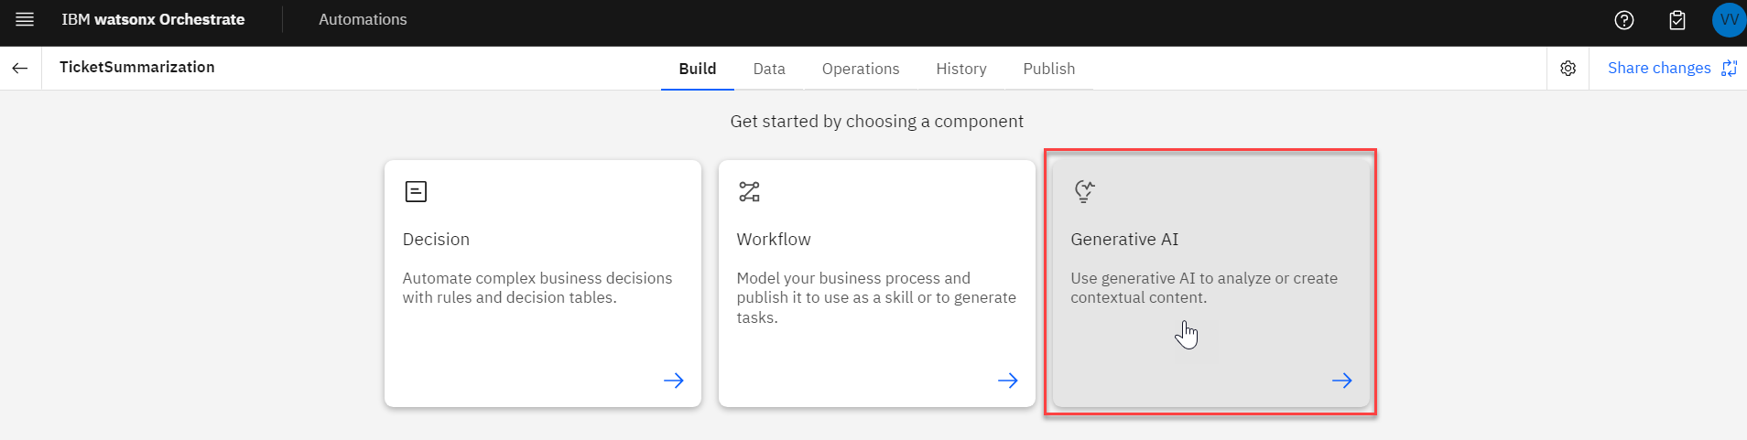

1. Provide the **Name** for your new component in the format "Your Initials - Ticket Summarization", optional **Description**, and click **Create** to create it.

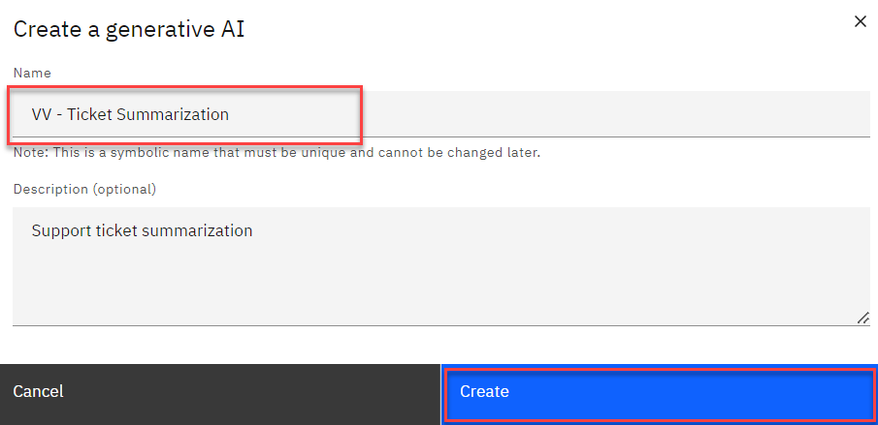

### Implementing and Customizing Generative AI Automation

1. Once you create the Generative AI component, you will be presented with the default **Prompt Builder** layout where you can implement and customize your new Generative AI automation skill. Take a minute to study the layout which allows you to:
2. Select the **LLM Model** the skill will be using
3. Provide **Context**, i.e. instructions for summarization
4. Use **Training examples** to improve results
5. Experiment with **Prompt input**
6. Add **Variables** to be used as Input for the new skill
7. **Test** your new automation before publishing it as a skill

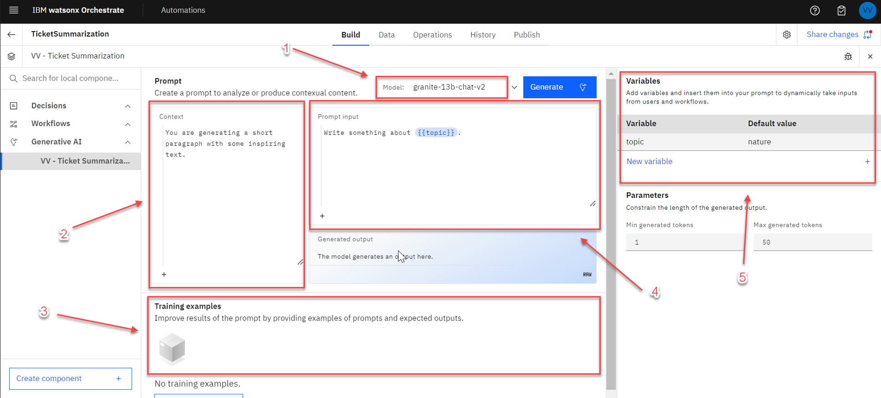

1. Start by creating new variables that will be used as input to the new Generative AI automation skill. To do so, click on New variable button and define the following variables:

* **Prompt Input** (no default value)
* **Instructions** (no default value)

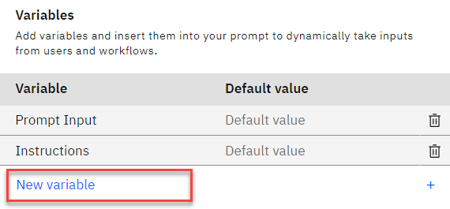

1. Update **Context** and **Prompt input** sections to leverage the new input variables. The variables are referenced using **{{variable}}** format. More specifically, enter the following values as shown in the screenshot below:

* *{{Instructions}}* in **Context** section
* *{{Prompt Input}}* in **Prompt input** section

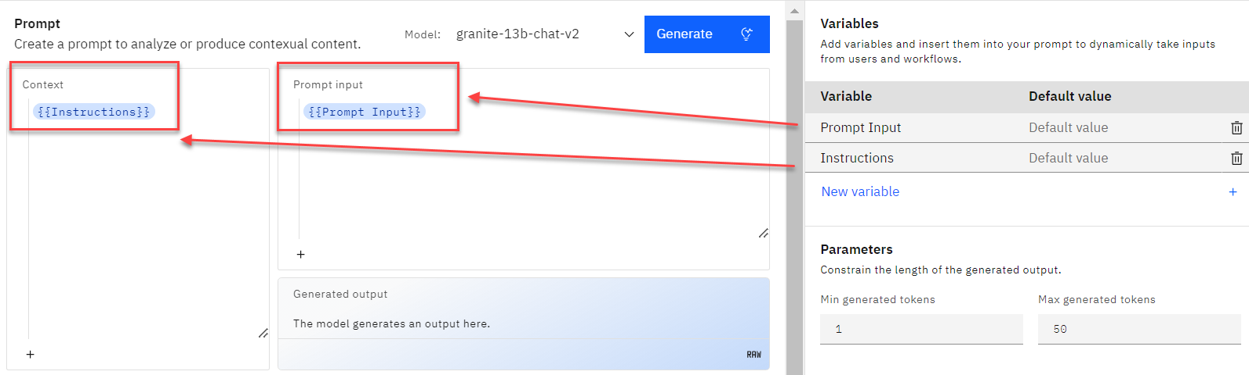

1. Refer to the following table for training examples and enter them in the **Training examples** section.

|  |  |
| --- | --- |
| **Input** | **Output** |
| Title: Bad Keyboard Description: Mary Williams said some of the keys on her laptop are sticking. When she types the H or K keys the output is multiple of the letter | Name: Mary Williams. Summary: Laptop keys are sticking possibly due to coffee spill. Issue with H and K keys |
| Title: Battery loses charge after one hour Description: Bill Jones says his laptop battery dies after one hour of use. This makes it difficult for him to work while he is commuting. He would like a replacement battery. | Name: Bill Jones. Summary: Laptop battery dies after one hour. |
| Title: Laptop crashing Description: Susan Taylor says her laptop crashes every few hours. She has lost work because of this. She updated to the latest OS but its still happening. Its been going on for 1 week. She tried re-installing the OS but her laptop keeps crashing not just one instance of the letter. Mary spilled coffee on her laptop 3 days ago. | Name: Susan Taylor. Summary: Laptop crashes every few hours. Has re-installed OS but issue continues. |

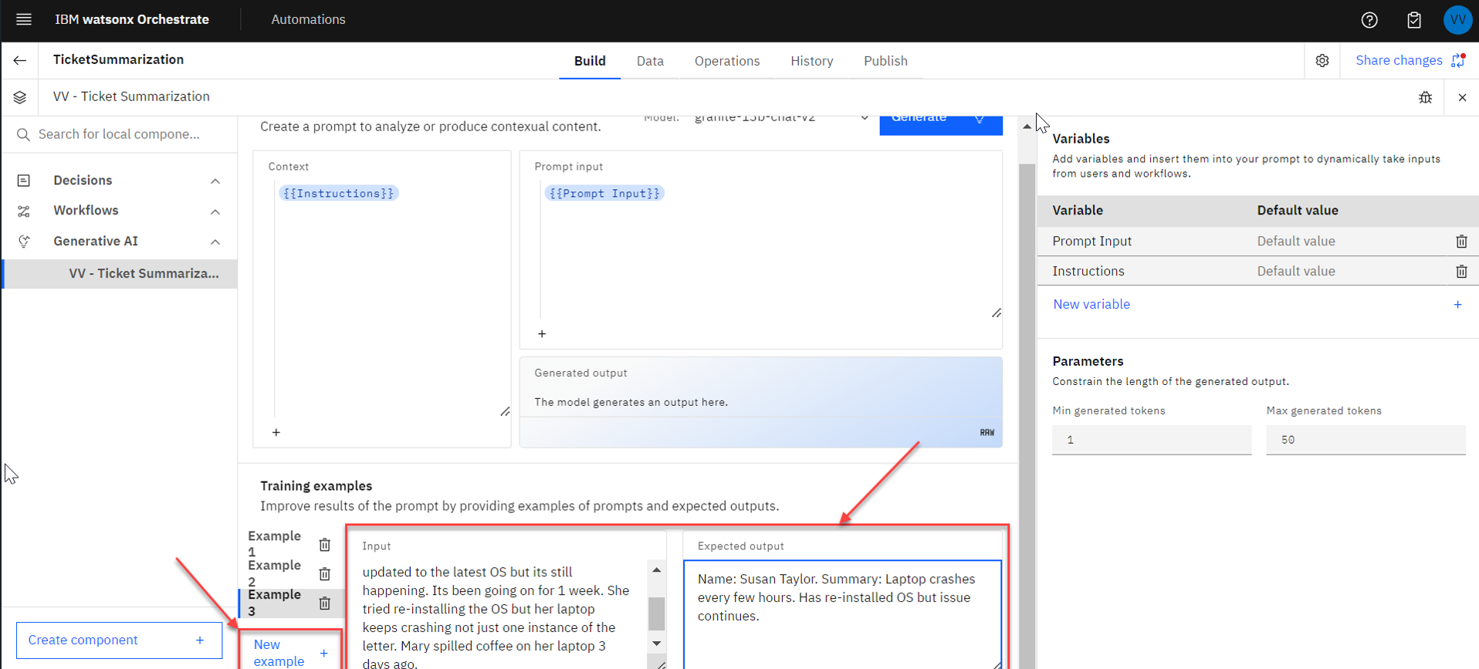

1. Change LLM model to **granite-13b-instruct-v2** in the "Model" section. You can also explore other models that are available out-of-the-box.

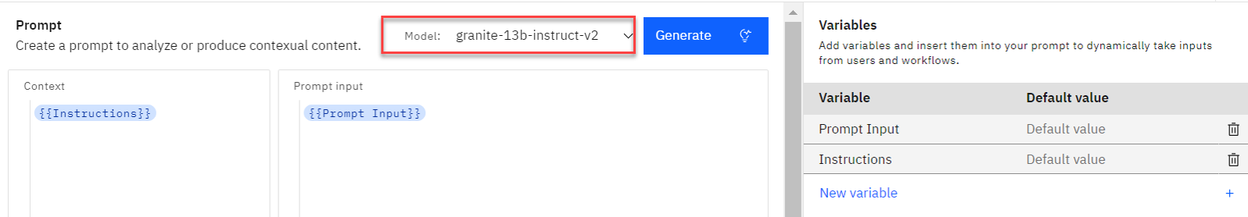

### Deploying and Publishing Generative AI Automation as a Skill

1. The first step is to create a new operation under **Operations** tab. Click on **Operations** tab, then on **Create operation** button.

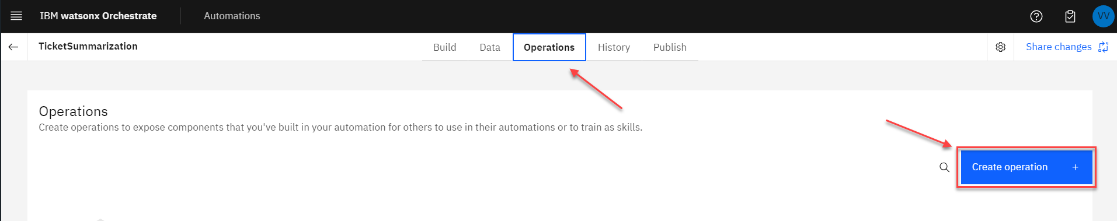

1. Provide a name for the operation in the **Operation name** field (make sure to use your initials for it to be unique e.g. **YourInitialsTicketSummarization**), select **Component** from the dropdown menu, and click on the **Save** button. The new operation will be available in the list under the Operations tab.

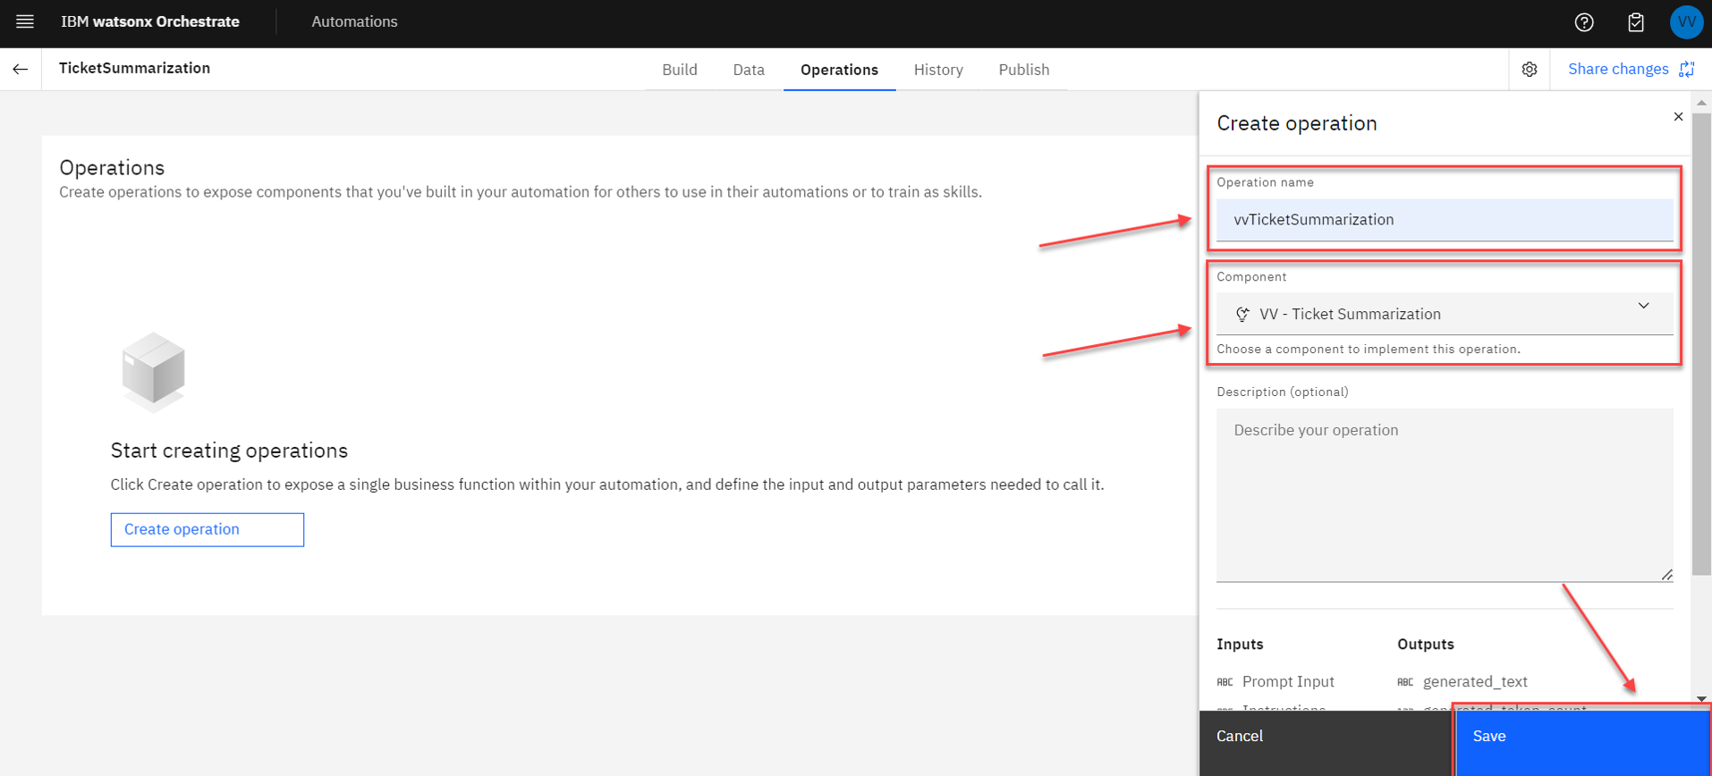

1. The next step during the deployment is to share the changes done to the Generative AI automation. Click on **Share changes** button in the top right corner of the screen:

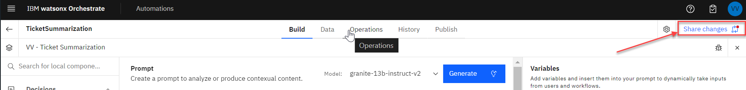

1. Review the changes and click on **Share** button, and then **Share** again.

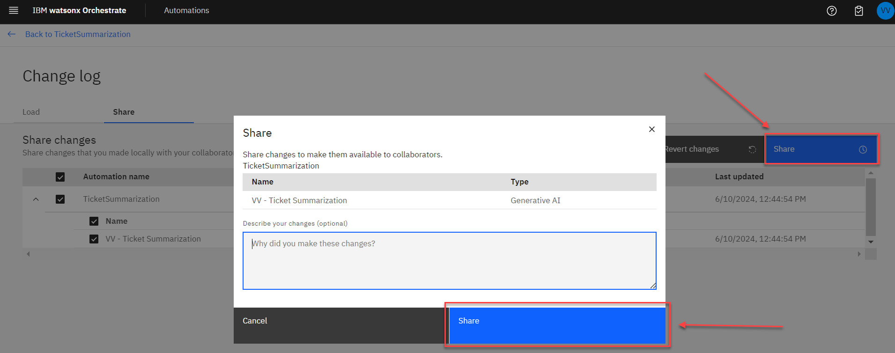

1. When the changes have been shared, click on **Back to TicketSummarization** link to return to the Build interface.



1. Next, click on **History** tab and then on **Version +** link for the most recent version of your automation.

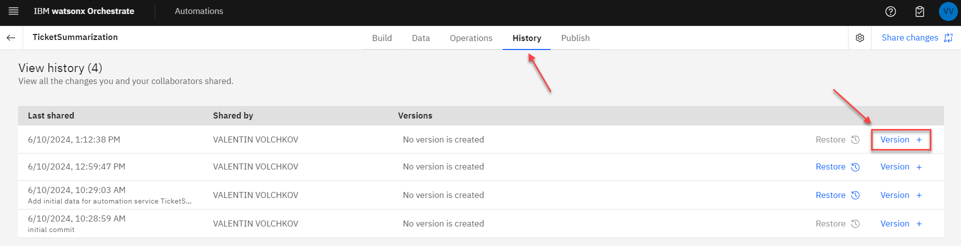

1. Specify **1.0.0** as the new version number in the **Name** field, and then click **Create** button. A new version of the automation will be created.

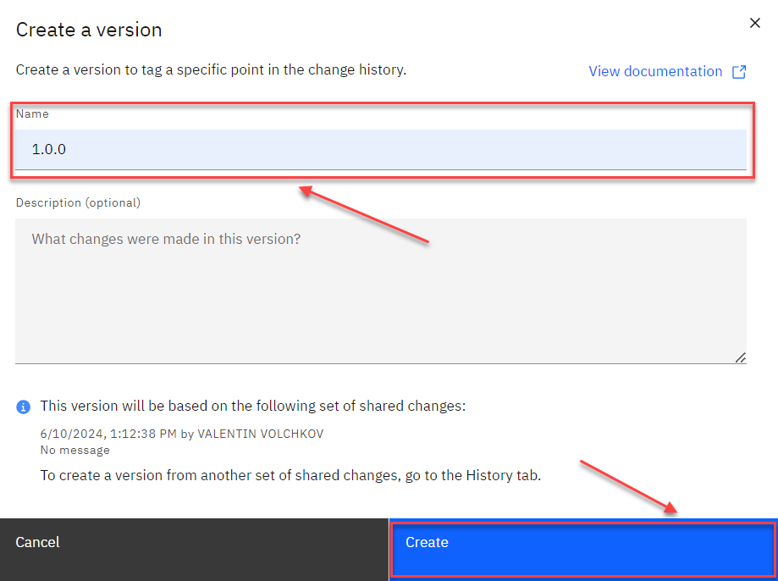

1. Lastly, click on **Publish** tab, expand the section corresponding to the most recent Version that has just been created, click **Publish** link, and then Publish button in the new dialog box to confirm. Wait until publishing is complete.

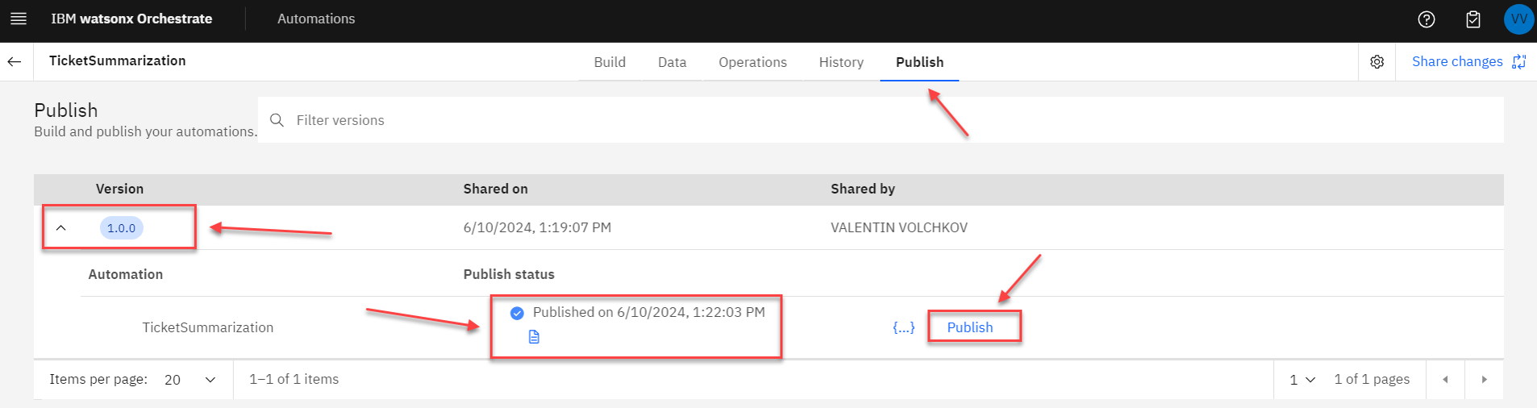

### Enhancing Generative AI Skill

1. Now that the new Generative AI automation has been added into the IBM watsonx Orchestrate catalog, the next step is to enhance the skill with expected inputs, adjust outputs, and provide initial phrases to be used in conversational UI. Click on the hamburger menu in the top left corner of the screen and select **Skill studio** in the menu.

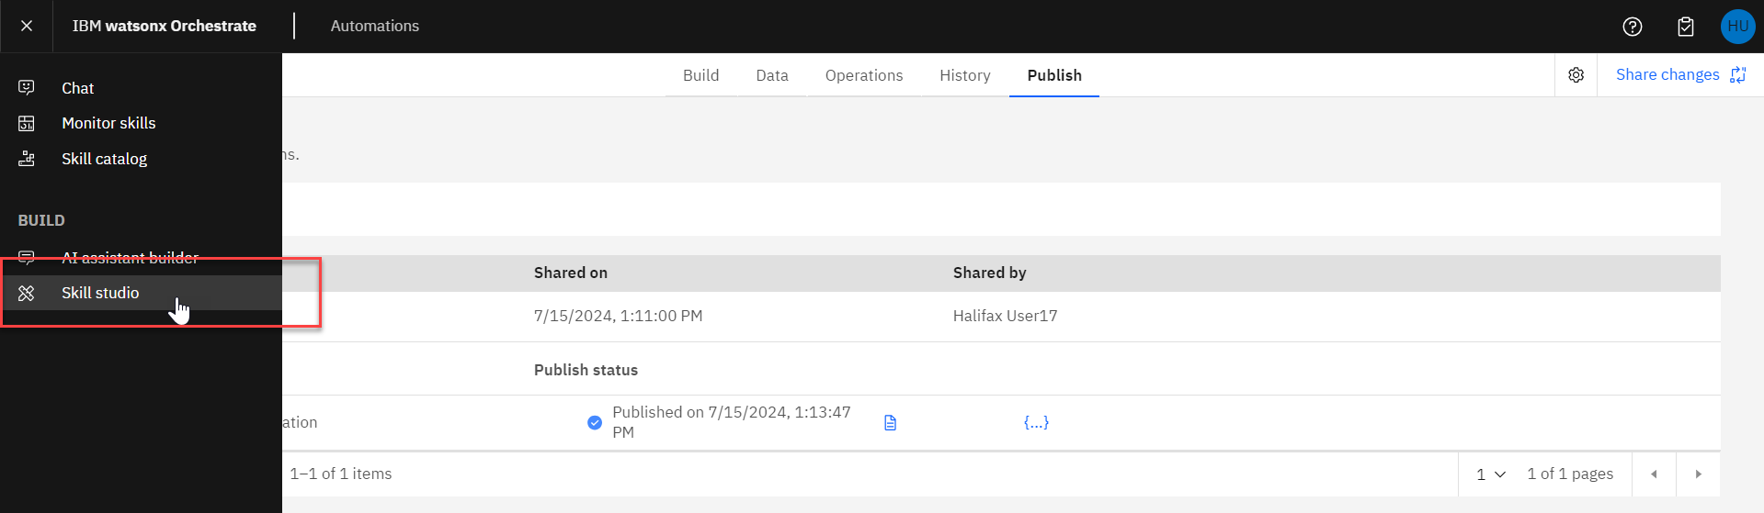

1. Under **Skills and apps** tab (**Skills** subtab), locate the skill that you have just added to the catalog (note that its status is **Ready to publish**), click on three dots and select **Enhance this skill** from the dropdown menu.

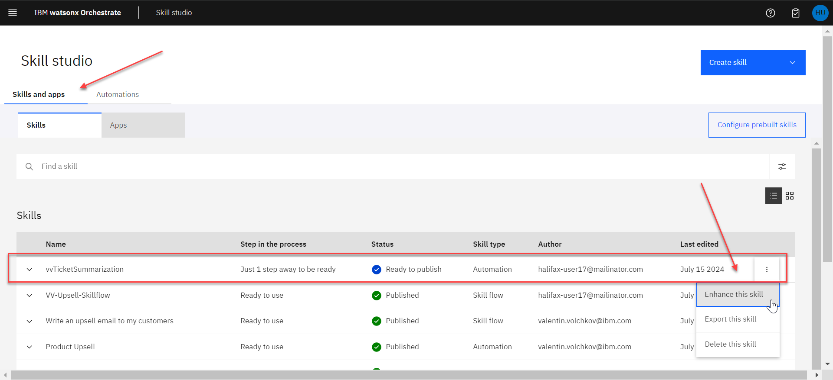

1. In the **Phrases** tab make sure to provide a couple phrases that a user may type to invoke this skill, e.g. "summarize ticket" or "summarize support ticket", and click on **Publish** once done:

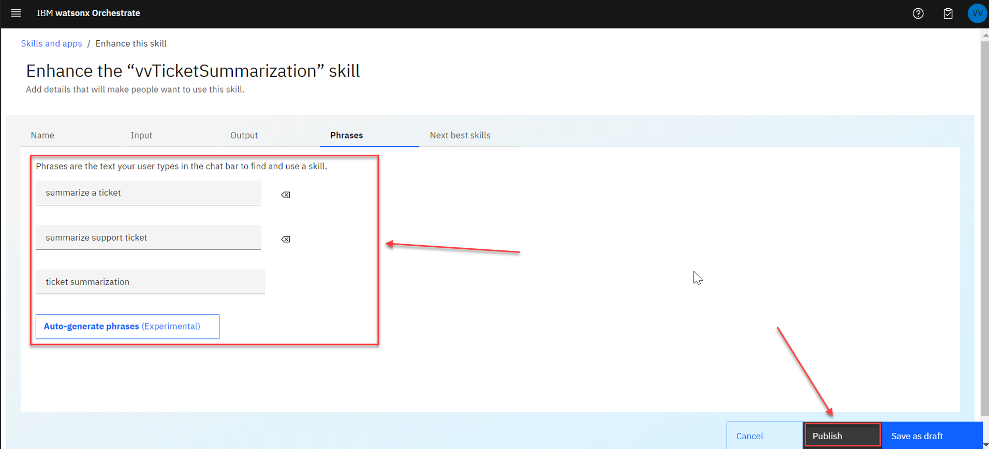

1. Note that when publishing is complete, the status of the skill changes to **Published** in the list.

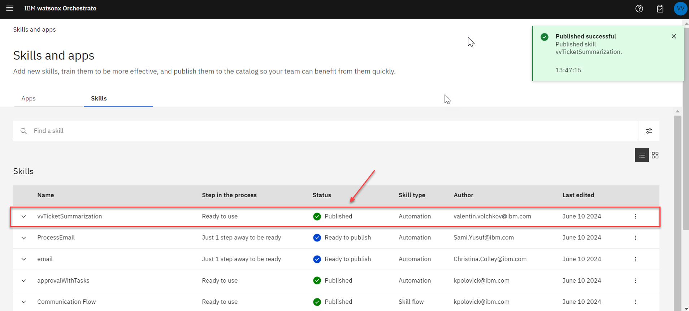

### Adding and Testing the Generative AI Skill

1. Now that the new Gen AI skill is published into the IBM watsonx Orchestrate catalog, the next step is to add it to the list of **Personal Skills** and test it in conversational UI of watsonx Orchestrate. Click on the hamburger menu in the top left corner of the screen and select **Chat** in the menu.

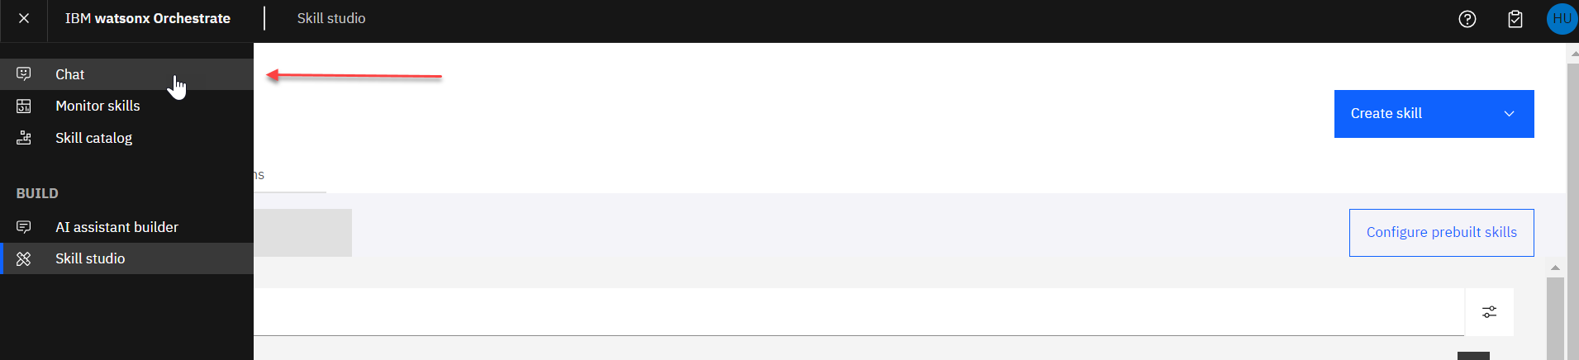

1. Click on Add skills from the catalog button.

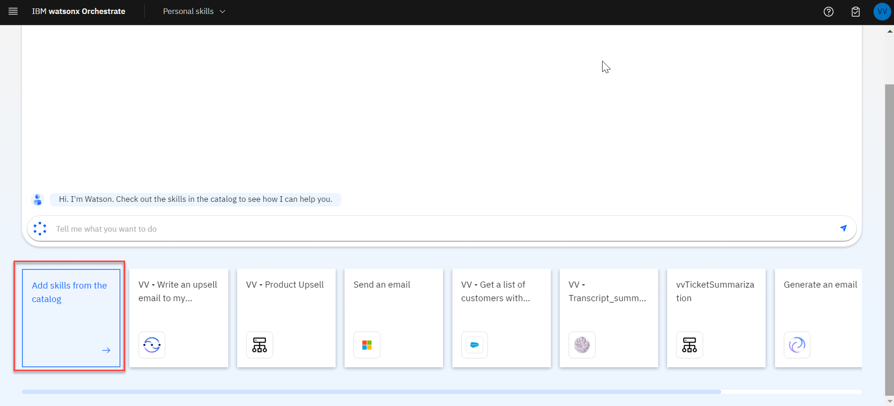

1. Search and locate your new skill in the catalog.

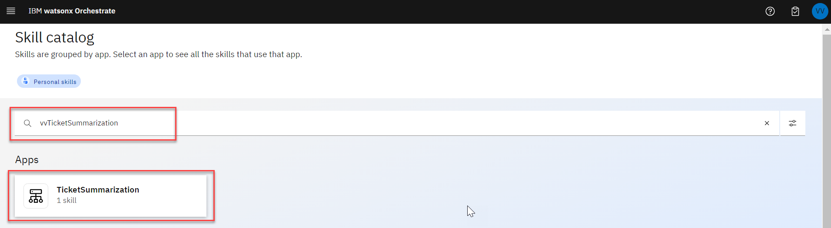

1. Click on "TicketSummarization" group and click on **Add skill** link to add it to the list of your Personal Skills.

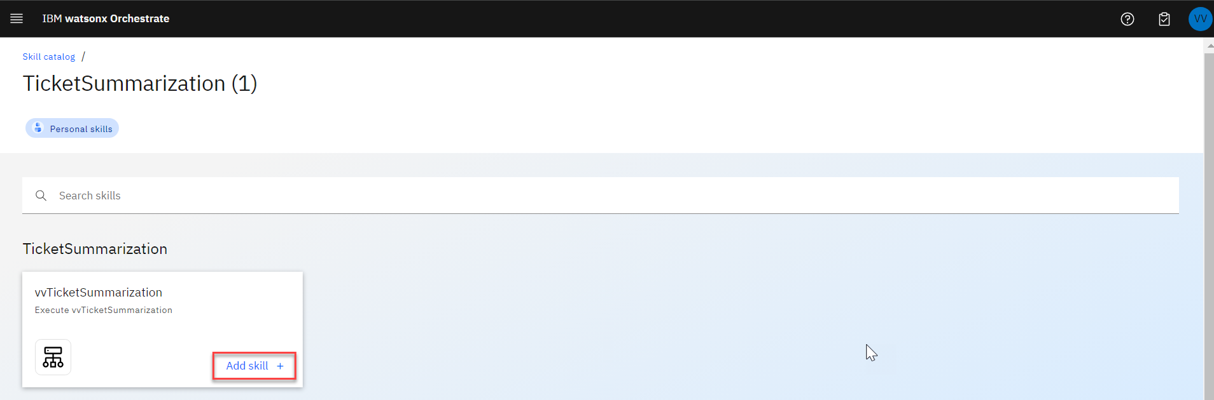

1. Return back to the conversational UI by selecting **Chat** in the hamburger menu in the top left corner of the screen. Notice that the new skill is available now.

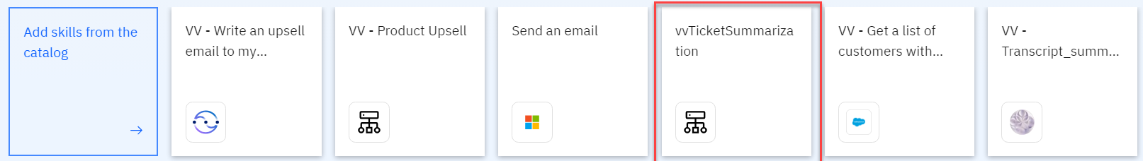

1. Click on the skill tile. Using the example in the table below, provide the input data and prompt instruction for the skill as shown below. Then click on **Apply**.

|  |  |
| --- | --- |
| **Input** | **Instruction** |
| Title: Printer not working Description: James Miller says printers on 5th floor, building D do not work. He has tried printing from all 3 printers on the floor and only one works but it prints in black and white only. James needs to print documents in color. This is an urgent request. James has client meeting in 4 days. | You are a summarization tool for customer support tickets. You receive a Title and Description for a support ticket and write a concise summary. Be sure to include a person's name in the output. |

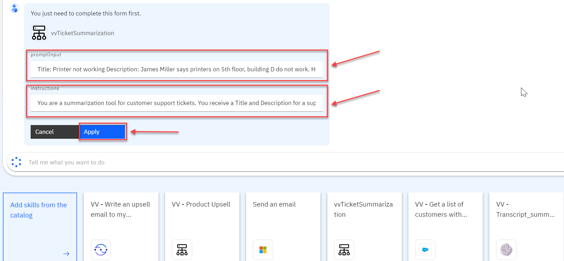

1. The new Generative AI automation will be executed. Validate the results.

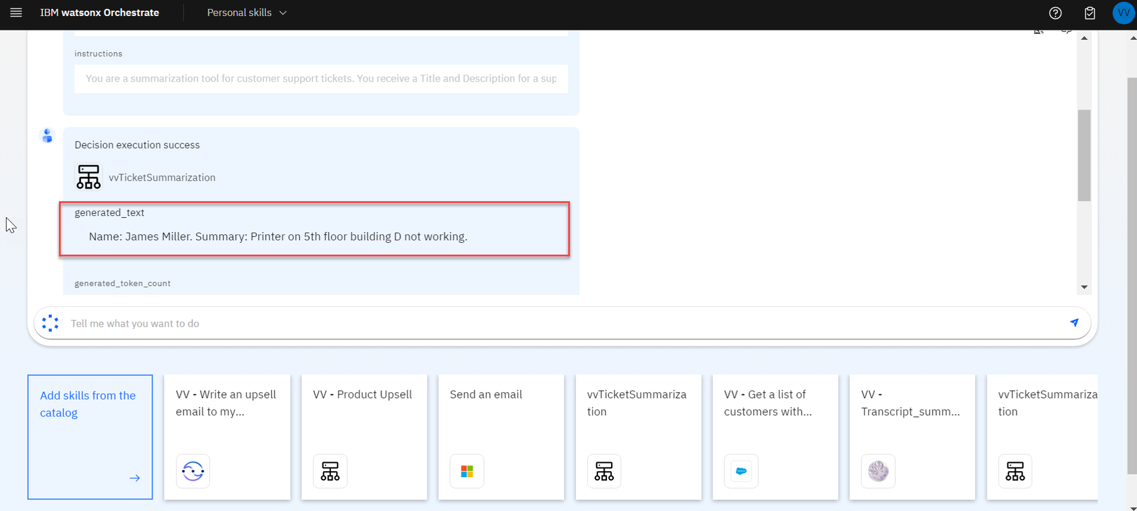

Notice that the ticket summary has been generated using the format provided in the instructions, i.e.:

**Name**: James Miller Summary: Printer on 5th floor building D not working.

You have just successfully created and invoked a Generative AI based automation skill which takes as input instructions and test input and returns a summary of the input using the instructions. The Generative AI based automation implements a few-shot prompt to an LLM, using several examples of customer support ticket summarization.

This concludes the lab. Thank you for your participation!

## Assistants (embedded IBM watsonx Assistant capability)

IBM watson**x** Orchestrate can also build **virtual assistants** by using the Assistant builder to create and deploy conversational Artificial Intelligence (AI) interfaces. These assistants can be tailored to fit both internal employee and external customer care use cases.

IBM has been delivering conversational AI for 10+ years and IBM watson**x** Assistant is a leader in the market.

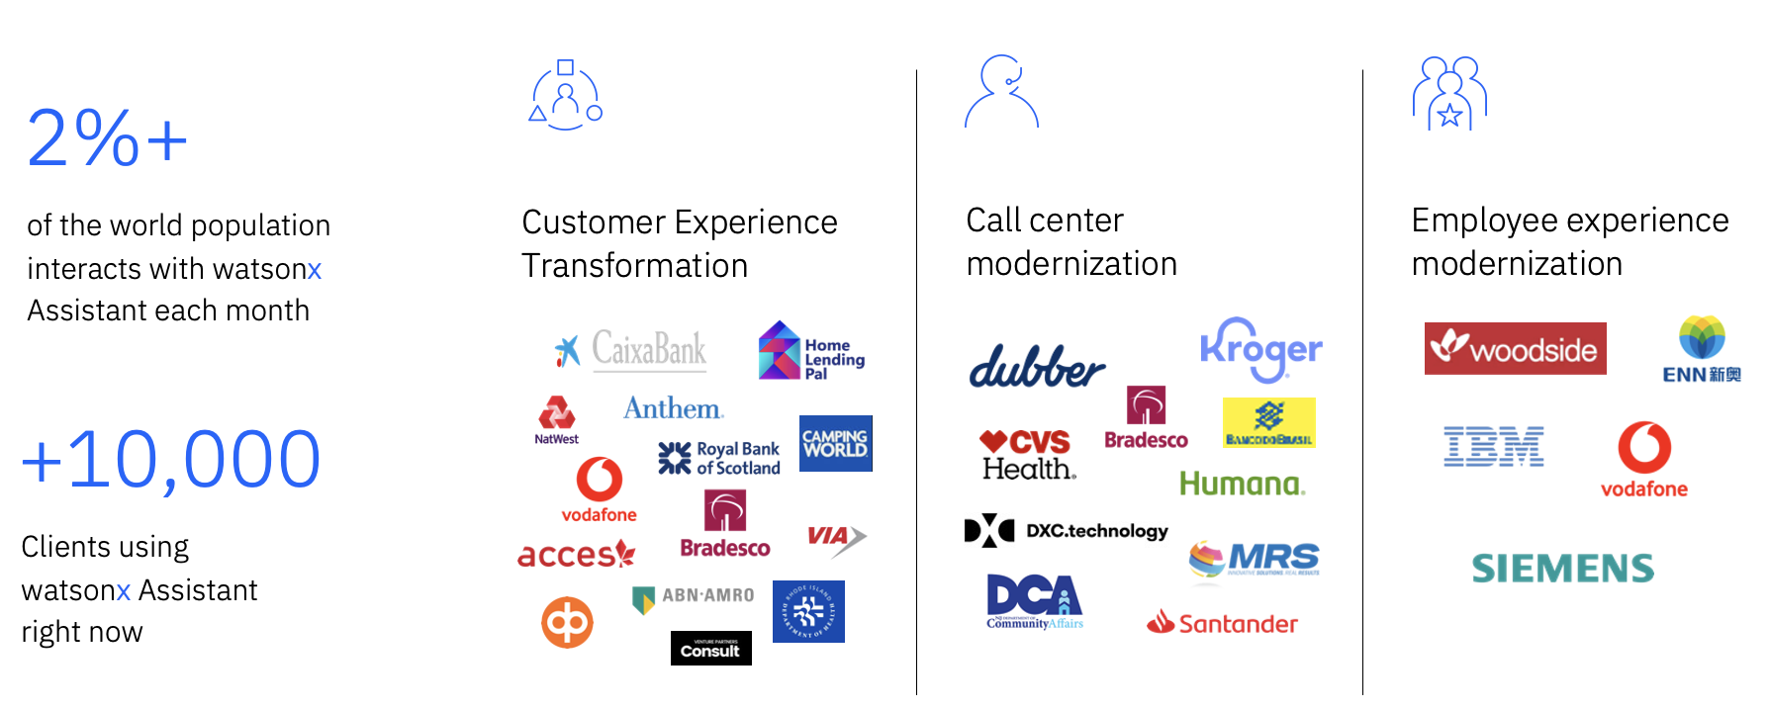

Now, when combining the advanced conversational AI capabilities of watson**x** Assistant with the skill-based approach of watson**x** Orchestrate, IBM opens a new scene for enterprise productivity.

There is a lot of public information on watson**x** Assistant, but to get started using it as part of Orchestrate, refer to these [instructions](https://www.ibm.com/docs/en/watson-orchestrate?topic=building-assistants).

**This concludes the lab exercise, congratulations! We hope you enjoyed it and would love to hear your feedback and any questions you might have. Your instructors are happy to answer your questions and help you to get started with IBM watsonx Orchestrate. Thank you!**